|  |
| --- |
|  |
| DenchiSoft  Karlsruhe, Germany    **vtubestudioapp@gmail.com**  https://denchisoft.github.io/ |

Version 1.5.0.a - 22.12.2020

VTube Studio – Official Documentation

Contact

[](https://discord.gg/RdaqJdu) [](https://twitter.com/VTubeStudio) [](mailto:vtubestudioapp@gmail.com)

<https://discord.gg/RdaqJdu> <https://twitter.com/VTubeStudio> [vtubestudioapp@gmail.com](mailto:vtubestudioapp@gmail.com)

Table of Contents

1 What is VTube Studio? 3

1.1 Introduction 3

1.2 Where to download? 3

1.3 Supported Devices 4

2 Android vs. iPhone/iPad: Which is better? 4

3 Getting Started 5

4 Loading your own Models 7

4.1 Preparing your Live2D model for VTube Studio 7

4.2 Putting your Live2D Model into VTube Studio 8

4.3 Auto-Setup 9

5 Loading your own Backgrounds 10

6 VTube Studio Settings 11

6.1 General Settings 11

6.2 Camera Settings 12

6.3 VTS Model Setting 13

6.3.1 Basic Setup 13

6.3.2 Model Movement 14

6.3.3 Physics Settings 14

6.3.4 VTS Parameter Setup 15

6.3.5 Supported INPUT parameters (face tracking, etc.) 16

6.3.6 Hotkey Settings and Types 16

6.3.7 Hotkey Actions 17

7 Expressions (a.k.a. „Stickers“ or „Emotes“) 18

8 Animations 20

9 Interaction between Animations, Expressions, Face Tracking, Physics, etc. 21

10 Streaming to Mac/PC 22

10.1 Preparation on PC/Mac 22

10.2 Connecting the Smartphone App 24

10.3 Recording with OBS (transparent background) 24

10.4 Using NDI for streaming to OBS with invisible UI (transparent background) 26

11 Connection Issues & Troubleshooting 27

11.1 Possible Causes for Connection Issues 28

11.2 Network Lag Troubleshooting (general) 29

11.3 Network Lag Troubleshooting (macOS and iPhone) 29

12 Taking/Sharing Screenshots 30

13 Item System 31

14 VTube Studio Files and File Format 33

15 FAQ 33

15.1 Can my face be accidentally revealed on stream? 33

15.2 How do I buy VTube Studio? Why should I? Can I use it commercially? 34

15.3 Can I try VTube Studio before buying it? 34

15.4 Can I use my webcam for face tracking instead of my smartphone? 34

15.5 How can I use VTube Studio together with my friends? 35

15.6 Can I use USB instead of WiFi to connect my smartphone? 35

15.7 What is the “Virtual Webcam” feature? 35

15.8 My device gets really hot! What is “Streaming Mode” in the smartphone app? 35

15.9 Are there differences between the macOS and Windows version? 36

15.10 Why does my stream to PC/Mac lag? 36

15.11 Why is blinking and eye tracking not supported on Android? 36

15.12 I bought the PRO version on Android. Can I transfer it to iOS? 36

15.13 VTube Studio doesn’t work on my smartphone. What can I do? 36

15.14 The face tracking is going crazy on my iPhone/iPad! What’s going on? 36

15.15 Why does my iPhone/iPad show the forward-pointing camera? 37

15.16 Where can I get help/support? 37

15.17 How can I become a VTube Studio Partner? 37

15.18 Can I use VTube Studio in my company? How about for TV ads? 37

15.19 I can’t load my Live2D model in VTube Studio. What’s wrong? 37

15.20 Does VTube Studio store/record any personal data? 37

15.21 Who is using VTube Studio? I want to see some examples! 37

16 Privacy Policy and Licensing 38

17 Further Terms 38

# What is VTube Studio?

## Introduction

VTube Studio is an app available for **iPhone, Android, macOS** and **Windows**. The app uses your smartphone to track your face and animate a [Live2D Cubism Model](https://www.live2d.com/en/) accordingly. The model is shown directly on your phone or on your PC by streaming the face-tracking data over your local network from your phone to your PC/Mac. **Example video:** <https://youtu.be/mN0sJXCubQw>

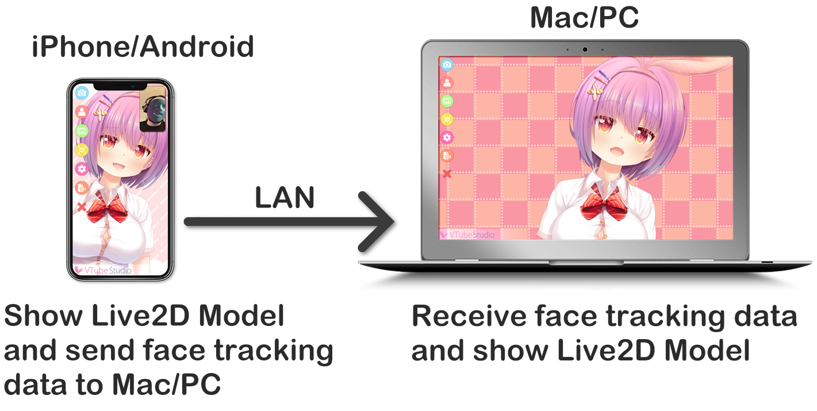

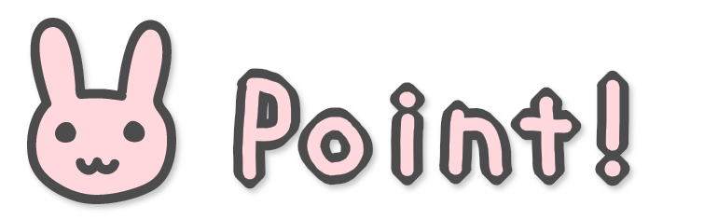

VTube Studio DOES NOT work with webcams.

* YOU ALWAYS NEED A SUPPORTED SMARTPHONE OR TABLET/IPAD.
* iPhone/iPad tracking is MUCH BETTER than Android tracking.
* Only Live2D models are supported, no VRM or other 2D/3D formats.

## Where to download?

To run VTube Studio, you need to download the smartphone app (Android or iOS) and the desktop app (Windows or macOS).

[](https://denchi.itch.io/vtube-studio)[](https://apps.apple.com/us/app/vtube-studio/id1511435444)[](https://play.google.com/store/apps/details?id=com.denchi.vtubestudio)

* **Desktop**
  + Windows: <https://denchi.itch.io/vtube-studio>
  + macOS: <https://denchi.itch.io/vtube-studio>

* **Smartphone**
  + iOS: <https://apps.apple.com/us/app/vtube-studio/id1511435444>
  + Android: <https://play.google.com/store/apps/details?id=com.denchi.vtubestudio>

The app itself is free to download. The free version has two restrictions, that can be removed by purchasing the PRO version (~25-30 USD). With the PRO version, you can:

* Remove the VTube Studio watermark from the smartphone.
* Stream face tracking data to your PC/Mac for more than 1 minute.
* Use VTube Studio for any commercial purposes, including monetized streams, superchats, etc.

No other features are restricted so far. Before purchasing the PRO version, please make sure the app works well on your device.

## Supported Devices

To run VTube Studio, you need a PC (Windows 7 and up) or Mac and a smartphone/tablet that supports the VTube Studio smartphone app. VTube Studio requires the augmented reality framework **ARCore** (from Google, on Android) or **ARKit** (from Apple, on iOS).

**Supported devices:**

* **Android**
  + Any device that supports ARCore should work.
  + See <https://developers.google.com/ar/discover/supported-devices>
  + Some devices may not work despite ARCore being supported. When this happens, the camera preview will show a blue rectangle. You can try manually downgrading to older versions of ARCore and see if that helps, otherwise you’ll have to wait until Google fixes support for your device in future versions.
* **iOS**
  + Any iPhone or iPad that has FaceID
    - iPhone X, iPhone XR, iPhone XS (regular and Max), iPhone 11 (regular, Pro and Pro Max),
    - iPad Pro (3rd, 4th+ generation)
  + Also supported: devices without FaceID but with the Apple A12 (or newer) Bionic Chip
    - iPhone SE 2020

# Android vs. iPhone/iPad: Which is better?

The smartphone face tracking is provided by Google ARCore on Android and Apple ARKit on iOS. ARKit face tracking on iOS is much more advanced when compared to ARCore on Android. This is partially due to the supported iOS devices having specialized hardware for face tracking (TrueDepth Camera).

In short, iOS devices are much better. They provide much smoother and more detailed tracking. Newer iPads or iPhones are generally preferable over older ones, as old ones may get warm/hot during usage (see also FAQ). Also, some important features are not supported on Android.

|  |  |  |
| --- | --- | --- |
| Feature | iOS | Android |
| Face Direction Tracking | Fully supported | Fully supported |
| Mouth Tracking | Smile + Mouth-Opening (no frown) | Smile + Mouth-Opening (no frown) |
| Brow Tracking | Individual brows up/down | One combined up/down value |
| Eye Tracking | Fully supported | Not supported |
| Blink/Wink Tracking | Fully supported | Not supported |
| Tongue/Cheek Tracking | Fully supported | Not supported |
| Face Tracking Delay | No or very small delay | Very small or small delay |

To add to that, the tracking on iOS is less shaky and needs less smoothing. This results in your model reacting a bit faster and movement looking more natural in general. To summarize**, if you want to take advantage of high-quality face tracking, the iOS version is the way to go**.

# Getting Started

Feel free to play around a bit by yourself inside the app! It comes with a few Live2D models, but of course you can also load your own ones (more on that later).

VTube Studio consists of the smartphone app (iOS/Android) and the PC app (Windows/macOS). They are very similar. Let’s look at the interface of the smartphone app first.

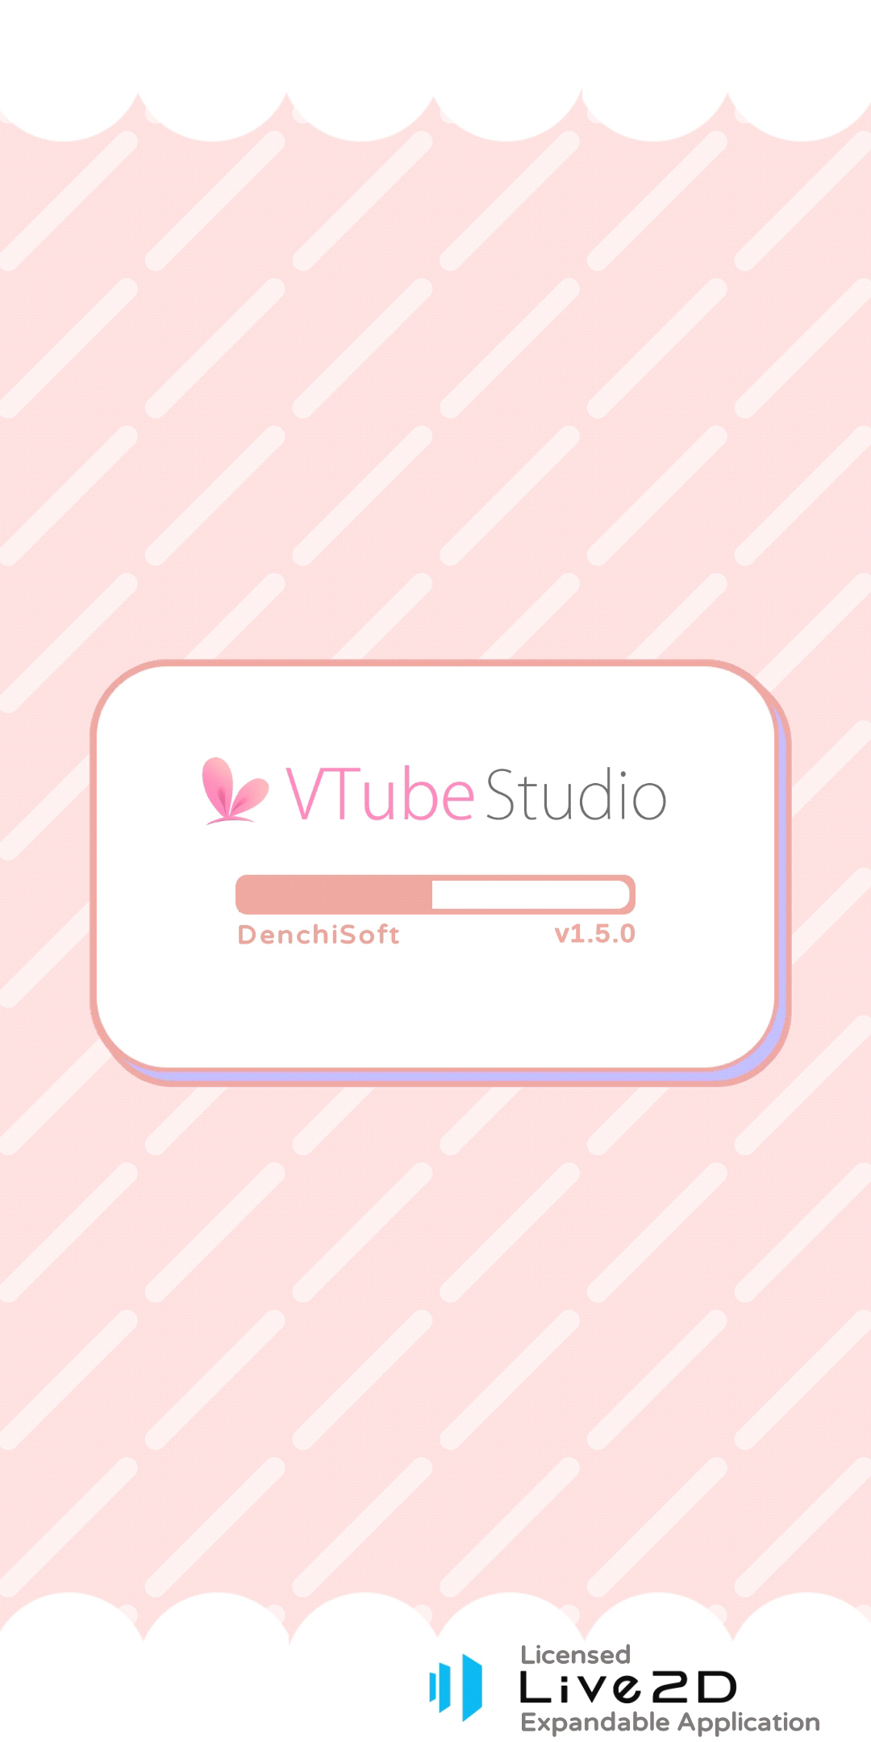 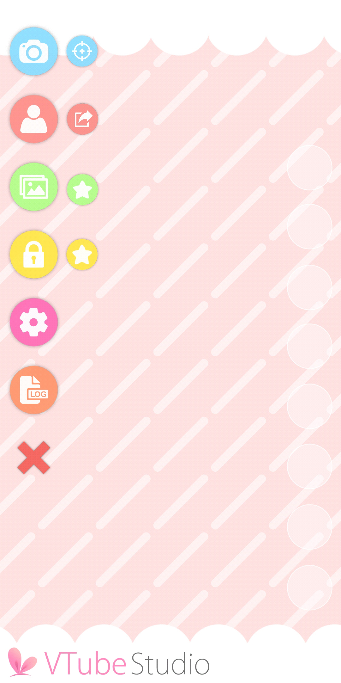 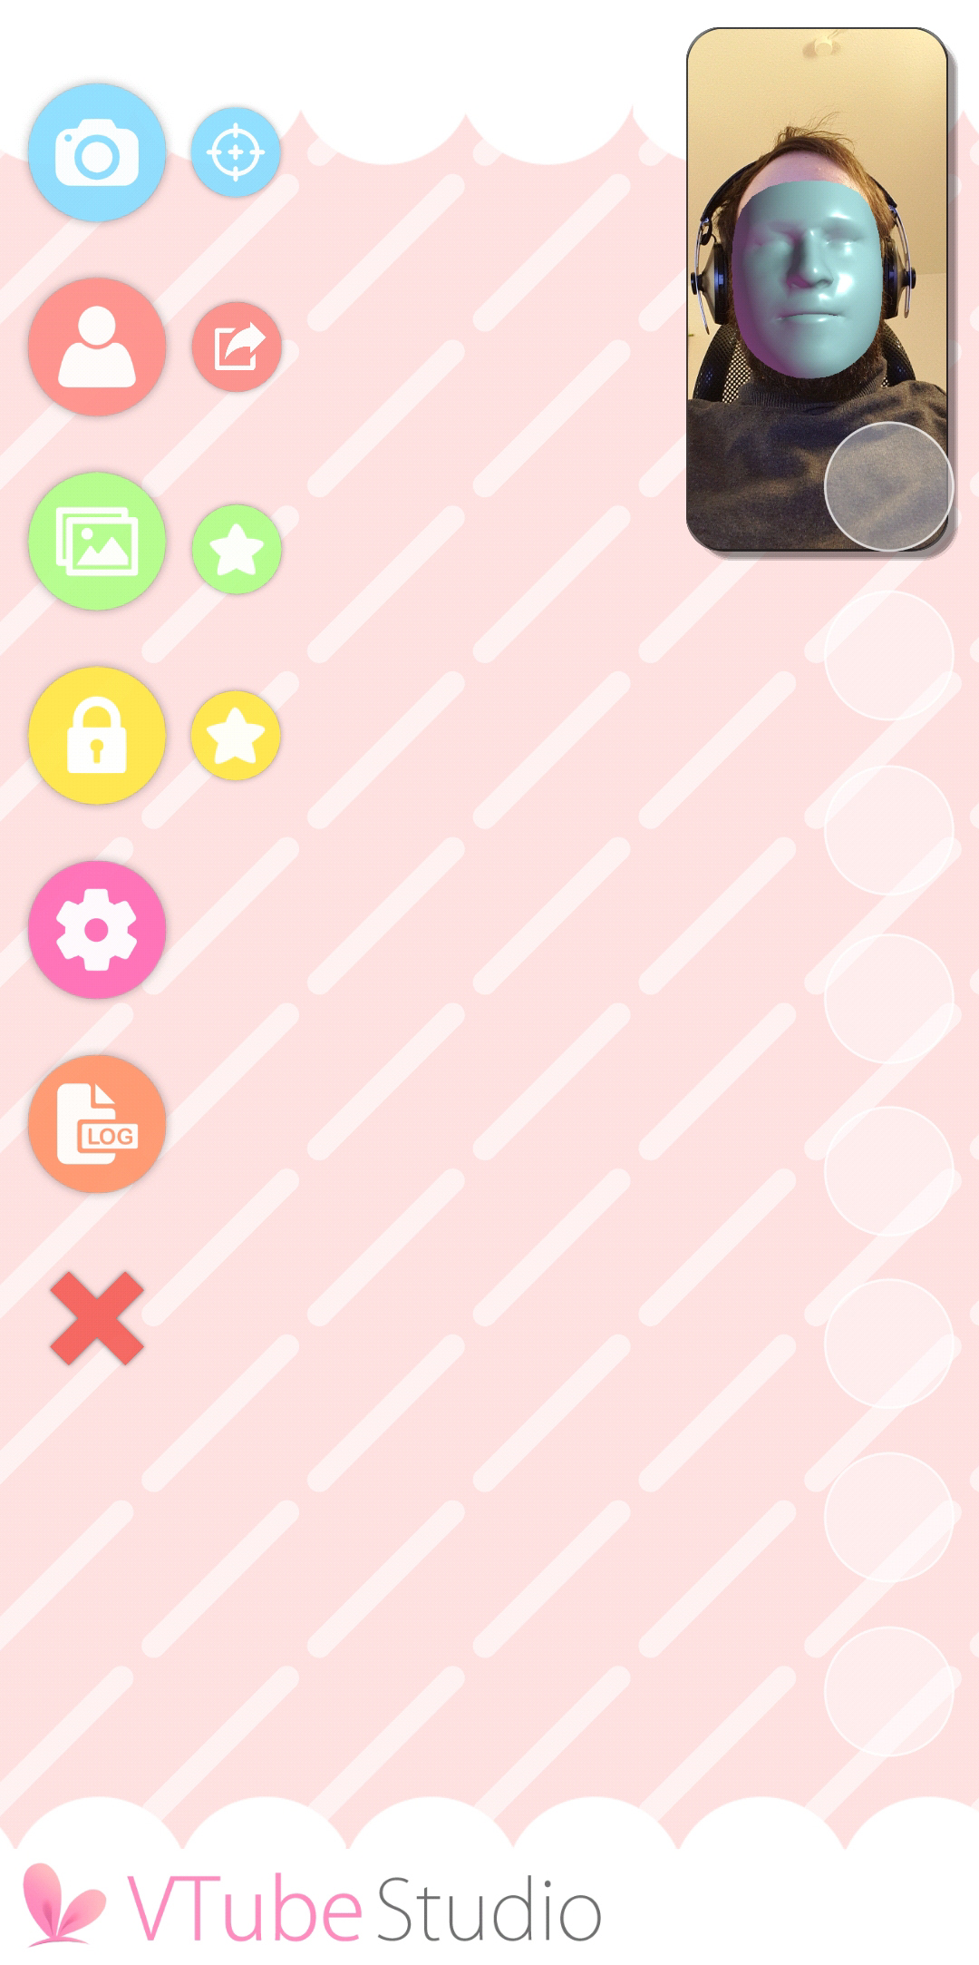

In the first image, you can see the VTube Studio loading screen. If you want to find out the version of the app you’re using, it’ll be shown right there.

The second image shows the main menu of the app. From there, you can access the main app functionality. From top to bottom:

* Show camera preview image (see also third image).
  + The icon next to it starts the camera calibration without showing the camera preview. You can also calibrate by clicking on the camera preview image when it’s shown.
* Show model selection bar.
  + The icon next to it opens the screenshot config. Using this, you can take screenshots directly from within the app, save them and share them on social media. Also supports PNG screenshots with transparent background.
* Change background (shows background selection list).
  + The icon next to it opens the item/prop system config to import items into the scene. See the chapter “Item System” for more info.
* Lock model position (will make sure you can’t accidentally move the model around when touching the screen, face tracking will still move/animate the model).
  + The icon next to it locks/unlocks all items in the scene. See the chapter “Item System” for more info.
* Show settings, including VTube Studio model and hotkey setup.
* Show logs (if you run into any issues/errors, check the log).
* Hide main menu icons. Double-clicking anywhere on the screen will show the menu icons again.

Now let’s see what happens when you click the “Show model selection bar” icon.

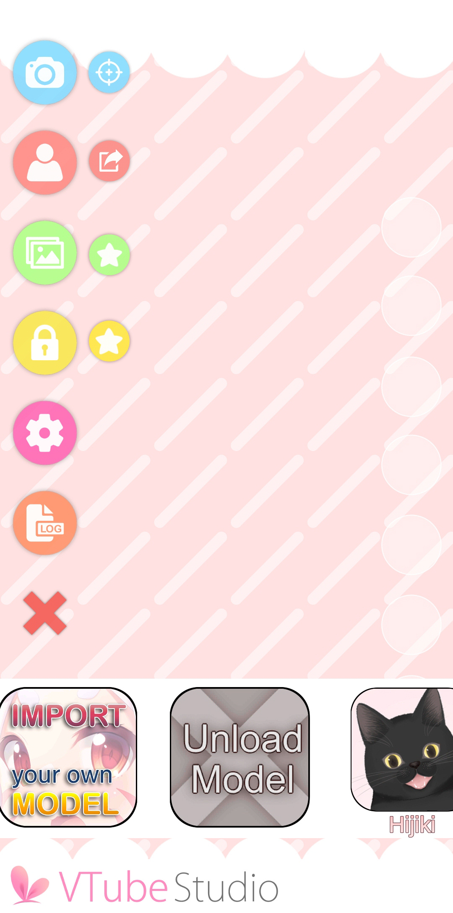 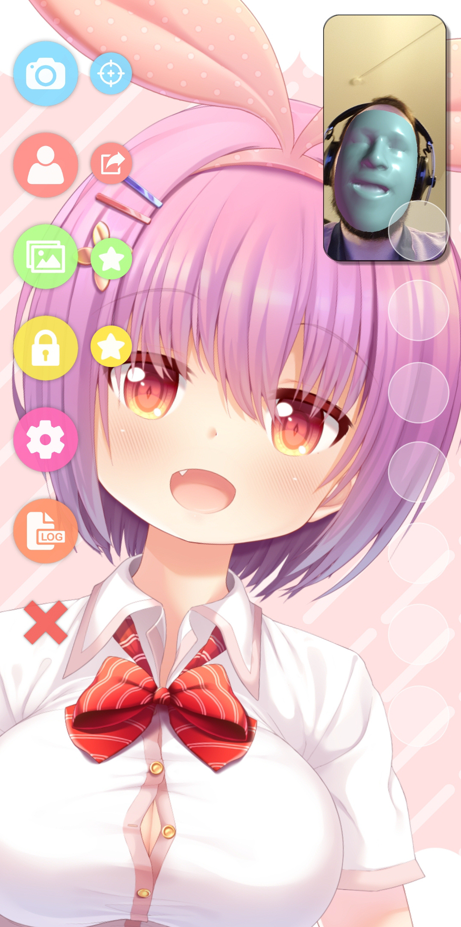 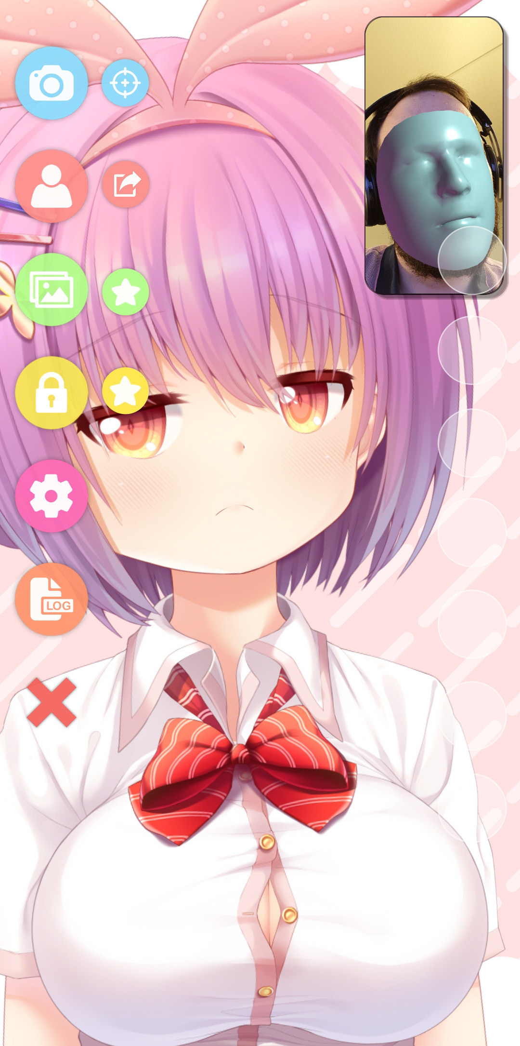

The first item will open a guide on how to load your own models into the app (this document). The second button will unload the model if a model is currently loaded.

The items after that are the models currently available in the app. VTube Studio comes with a couple example models for you to play around with. After clicking a model, it’ll be loaded into the scene. If the model is not yet configured, you’ll be asked to run the **“Auto-Setup”** for iOS or Android which will set the model up based on default Live2D parameter names and value ranges. This will be covered later.

Once the model is properly configured, the model will imitate your movement and facial expressions. You can move, rotate and scale the model with the usual touch gestures. When opening a model in the PC app, the controls for moving/rotating/scaling will be shown on the screen.

You can close the camera preview at any time. There is no reason to keep it open. You can click the camera preview window to calibrate the face tracking. While doing this, keep your face at a normal distance from the camera with a neutral expression on your face. This is especially important on Android, iOS only needs calibration to reset the face direction.

# Loading your own Models

VTube Studio comes with a few default models. Most of them belong to *Live2D Inc.*, so please be sure to read the chapter **“Privacy Policy and Licensing”** if you want to use them in your streams.

This chapter covers how to load your own Live2D models into VTube Studio. It will be assumed that you already have your Live2D model finished and have a basic understanding what Live2D is and how it works (Live2D parameters, etc.)

## Preparing your Live2D model for VTube Studio

There isn’t really any specific special preparation you need to do with your Live2D model so it works with VTube Studio. As explained in the chapter **“VTS Parameter Setup”**, you can map any face tracking parameter to any Live2D parameter, so you could theoretically choose parameter IDs and ranges however you want.

However, it is recommended to adhere to the default IDs and parameter ranges (min/max). Please also note that only the Live2D parameter IDs matter to VTube Studio, not the Live2D parameter names.

When you’re done with your model, export it via **File 🡪 Export For Runtime 🡪 Export as .moc3 file**

Make sure to choose the following settings:

* “Export Version” set to “SDK 3.0” or “SDK 3.3” or “SDK 4.0” (recommended).
* “Export Physics settings file (physics3.json)”. If you don’t to this, your model will not have physics. Always export your physics file like this and never independently from the model, as this is the only way to make sure the physics file is “registered” with the model (in the .model3.json file) so it’s usable by VTube Studio.
* Export Types: SDK

This will create a folder with the following files (ignore the files marked red). If your model fails to load later in VTube Studio, make sure all files are there.

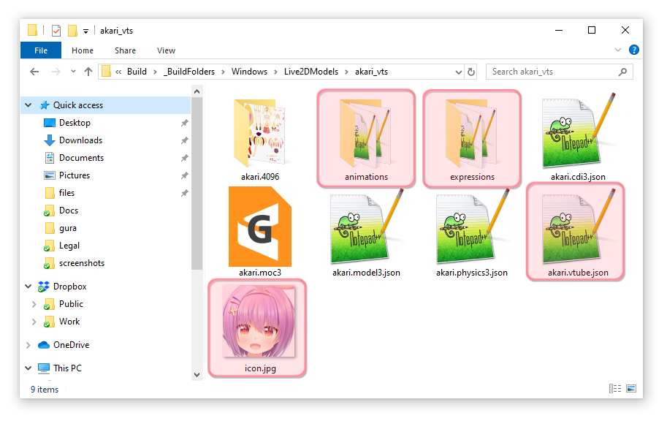

A short overview about what these files do:

* **<model>.model3.json**
  + Main Live2D model index file.
  + Human-readable (can be opened/edited in text-editor)
  + Has references to all other files. VTube Studio looks for this file.
* **<model>.moc3**
  + Model binary file. Has all model data, such as vertices, deformers, parameters, etc.
* **<model>.cdi3.json**
  + Model display information file.
  + Human-readable.
* **<model>.physics3.json**
  + Has all the information about your physics setup.
  + Human-readable.
* <**model>.<resolution> (here: akari.4096)**
  + Contains your texture(s). VTube Studio also supports models with multiple and/or large textures. Be advised that using large textures may lag or even crash the app on mobile.

Make sure you have all these files in a folder before you proceed. I usually call this folder **<model>_vts**, but you can choose any name.

If you want to use Live2D Animations and Live2D Expressions, put them in this folder as well or in a subfolder (see the two folders in the screenshot above). How expressions and animations work will be explained later. You should also add a model icon into that folder (any filename, .png or .jpg, recommended 512x512 pixels).

## Putting your Live2D Model into VTube Studio

Take your model folder and put it in the “Live2DModels”-Folder in VTube Studio. Where this folder is located differs depending on the platform:

|  |  |
| --- | --- |
| Platform | Folder Location |
| iOS | Open **VTube Studio app data folder** on your iPhone/iPad in iTunes (Windows or macOS) or Finder (on macOS Catalina). You’ll find a Live2DModels-Folder.     * Copy Live2DModels -Folder to your desktop * Put your new model folder file into that folder * Copy Live2DModels-Folder back into your iPhone/iPad (overwrite the old folder) |
| Android | **<Your Phone>**/Android/data/com.denchi.vtubestudio/files/Live2DModels |
| MacOS | **VtubeStudio.app**/Contents/Resources/Data/StreamingAssets/Live2DModels |
| Windows | **<VTubeStudio.exe-Path>/**Vtube Studio_Data/StreamingAssets/Live2DModels |

Now start VTube Studio. When the app is started, it automatically looks for new Live2D models and creates a VTube Studio Model (VTS Model, **<Live2D-Model-Name>.vtube.json**) in the same folder. This file is human-readable and contains all information about your VTube Studio model setup.

You should now be able to see your model in the model selection bar. If not, make sure all files are present and there are no errors in the logs.

## Auto-Setup

When loading a new Live2D model, you will be asked to run the “Auto-Setup”. The Auto-Setup can be triggered manually as well after the model is loaded.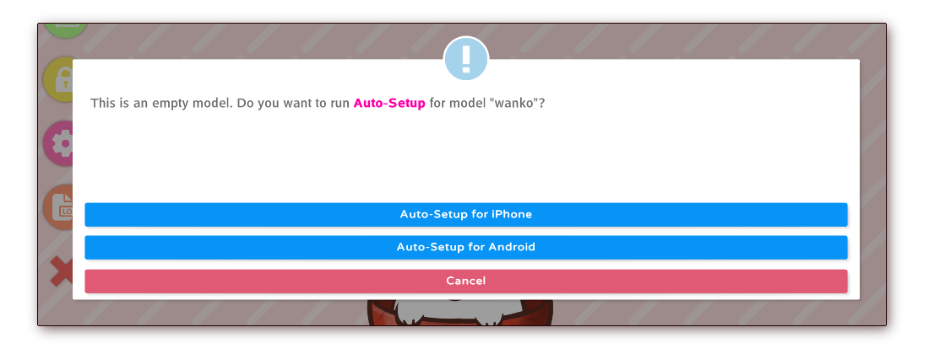

When running the Auto-Setup for iOS or Android, VTube Studio will automatically look for default Live2D parameters in your model. VTube Studio will assume that you have used default Live2D parameter IDs and parameter names and set up your VTube Studio accordingly. You can learn more about the default IDs here: [https://docs.live2d.com/cubism-editor-manual/standard-parametor-list/#](https://docs.live2d.com/cubism-editor-manual/standard-parametor-list/)

If you do not use the default IDs, you will have to set your model up manually. This is explained in detail in the chapter **“VTS Parameter Setup”**.

The model will be optimized for use with either Android or iOS depending on which option you choose.

Your model should now be ready to use. Of course, you may need to finetune it, but it should move already. On iOS, you might have to open the camera preview once after installing the app before the model will move.

The whole process is also explained in this video:

**[VTube Studio] Loading your own Live2D Models --** <https://www.youtube.com/watch?v=AssUd6EtFXw>

# Loading your own Backgrounds

VTube Studio comes with a few default backgrounds. Some of them are animated backgrounds that can’t be added or removed (for example the doggo one).

The PC app also comes with a color-picker-background, pictured below. Using this background, you can also activate “Transparent Mode”, which will enable OBS and other capture software to record your model with a transparent background, so you don’t need to use a color key.

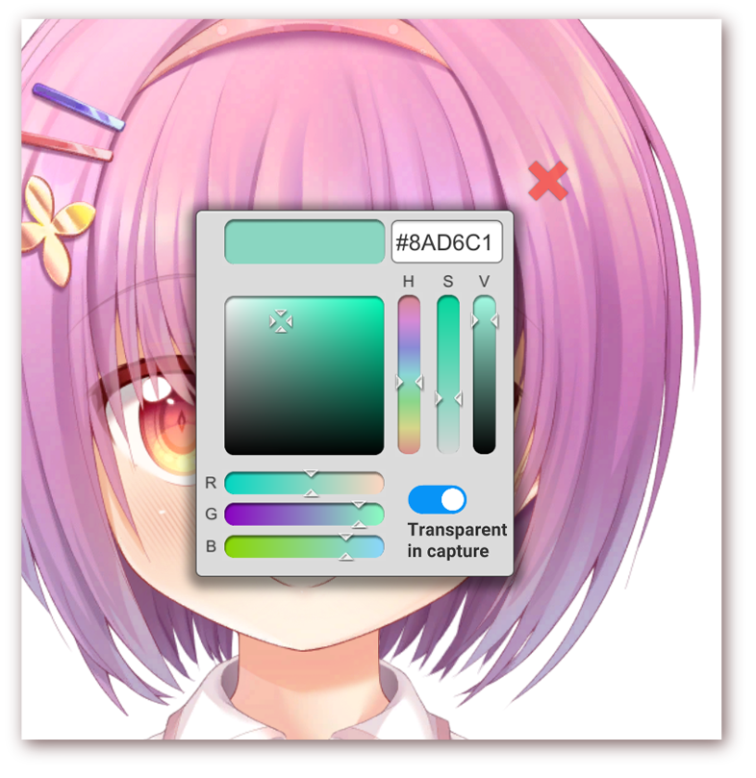

You can freely add backgrounds (videos or images) to VTube Studio. Be careful when using videos with a large file size in the mobile app as they could potentially crash the app due to memory limitations.

Supported formats are:

* **Image**
  + .jpg
  + .png
* **Video**
  + .mp4
  + .webm (may not be supported on some platforms)

The backgrounds-folder can be found in the following locations. You may need to restart the app after adding your own backgrounds.

|  |  |
| --- | --- |
| Platform | Folder Location |
| iOS | Open **VTube Studio app data folder** on your iPhone/iPad in iTunes (Windows or macOS) or Finder (on macOS Catalina). You’ll find a Backgrounds-Folder.     * Copy Backgrounds-Folder to your desktop * Put your new background file into that folder * Copy Backgrounds-Folder back into your iPhone/iPad (overwrite the old folder) |
| Android | **<Your Phone>**/Android/data/com.denchi.vtubestudio/files/Backgrounds |
| MacOS | **VtubeStudio.app**/Contents/Resources/Data/StreamingAssets/Backgrounds |
| Windows | **<VTubeStudio.exe-Path>/**Vtube Studio_Data/StreamingAssets/Backgrounds |

# VTube Studio Settings

After clicking the settings icon in the main menu, the settings screen will be shown. It has several tabs, a help icon (links to this document) and a language selector button that changes between Japanese and English (app restart needed).

## General Settings

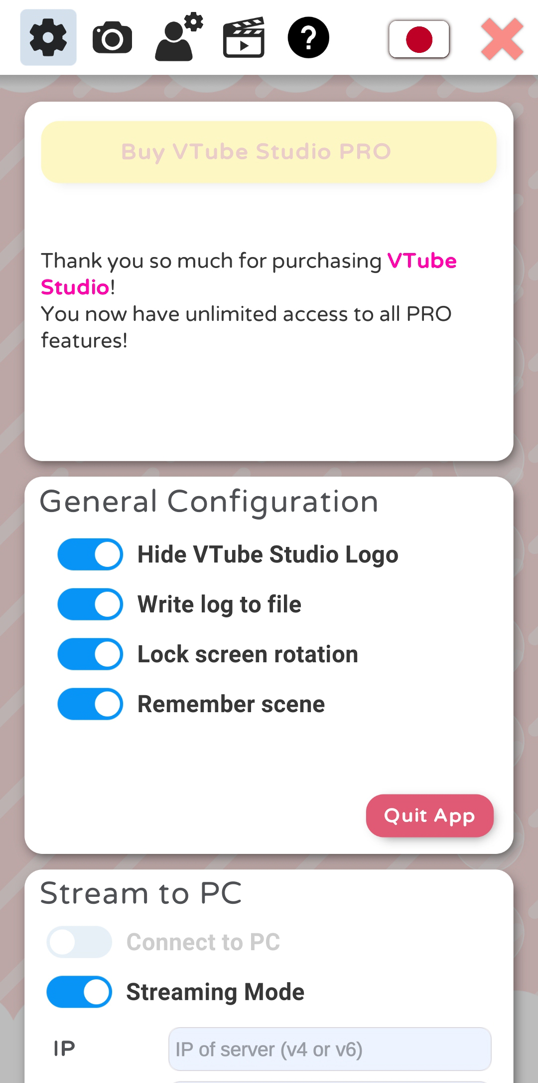 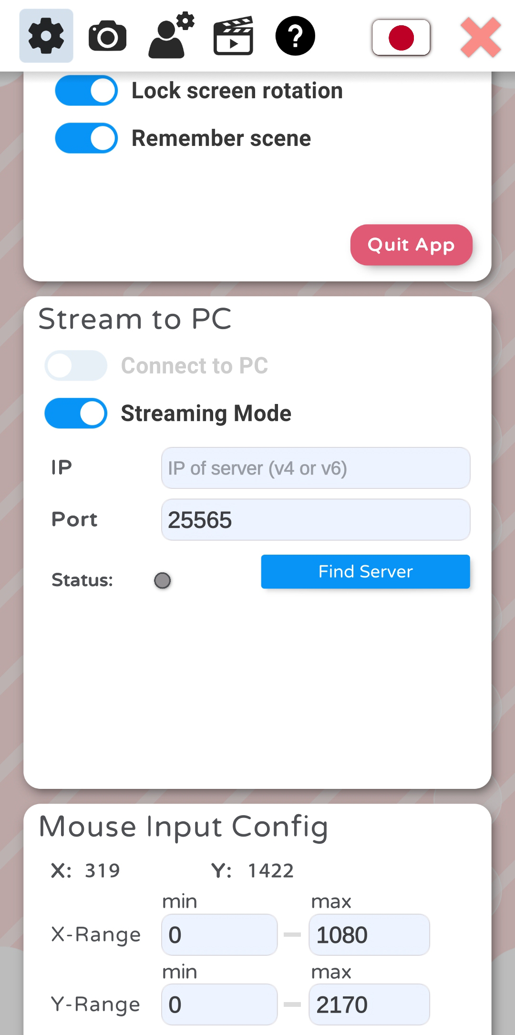 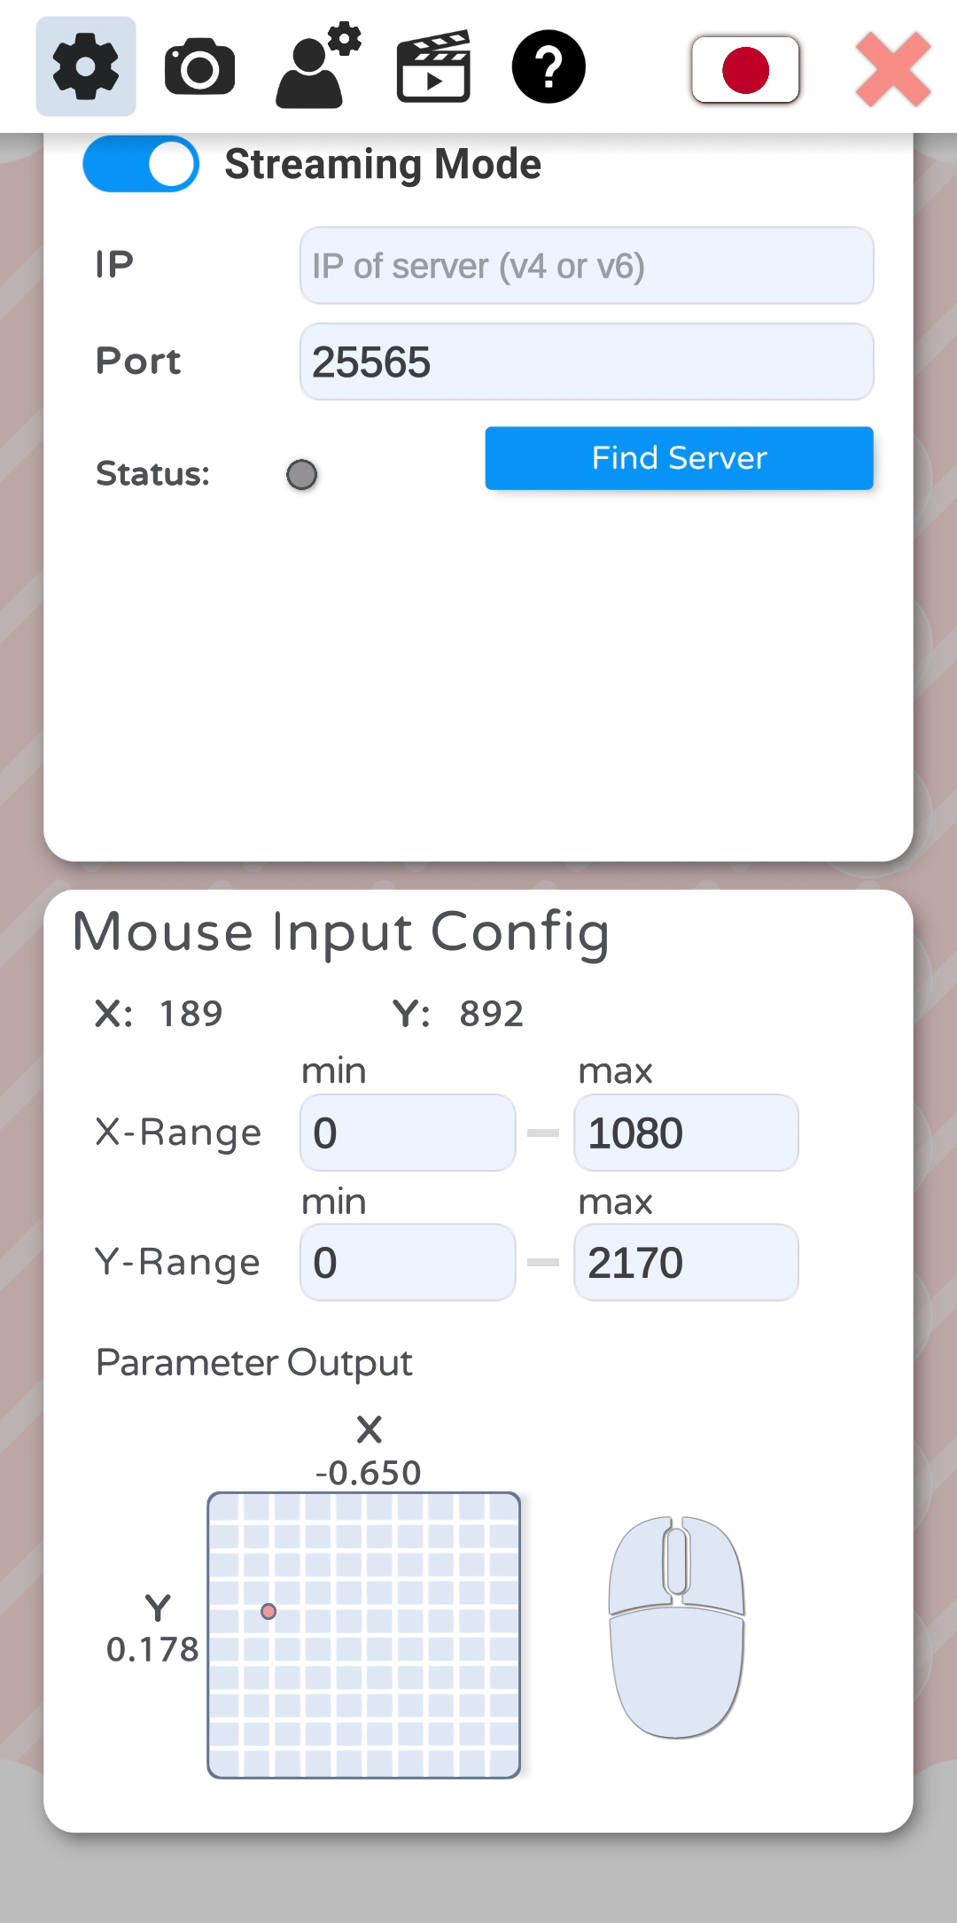

From here, you can purchase VTube Studio PRO. On iOS, there is also a button to restore purchases on this screen.

Furthermore, there are some general settings for hiding the VTS logo, remembering the scene (save open background and model when restarting), etc.

Next, there’s the “Stream to PC” setup. This is for connecting your phone to your PC to stream the face tracking data to the PC app. This will be covered in the chapter **“Connecting your Smartphone to your PC/Mac”.**

Finally, there’s the “Mouse Input Config”. This allows you to use the mouse/finger position as input parameter to animate your model in addition to face tracking. You can select an **X-Range** and **Y-Range** in pixels. This range will be mapped to [-1, 1] for X and Y. With this setting, you could for example make your model follow your finger or mouse pointer with its eyes. This will also show mouse-clicks (right, left, middle) that can be used to trigger hotkeys. In the smartphone app, these mouse-clicks can be triggered by touching the screen with one finger (left-click), two fingers (right-click) and three fingers (middle-click).

## Camera Settings

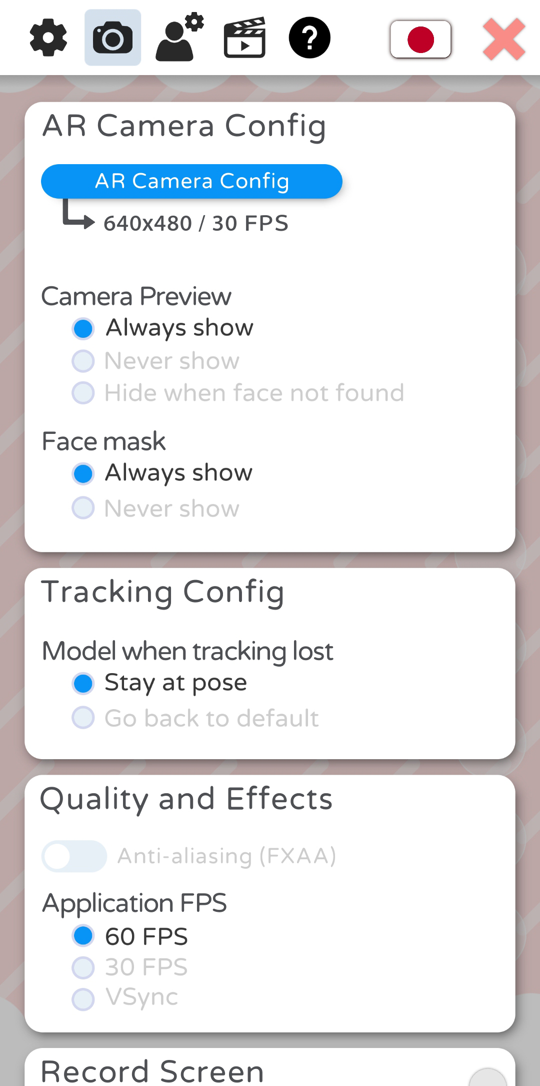 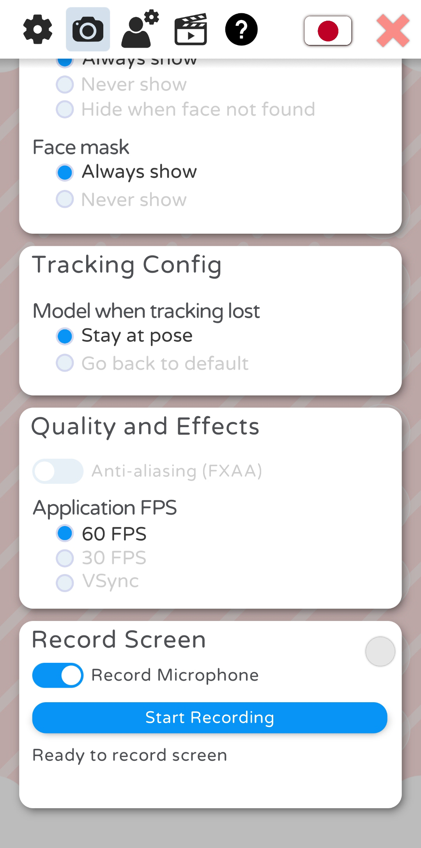 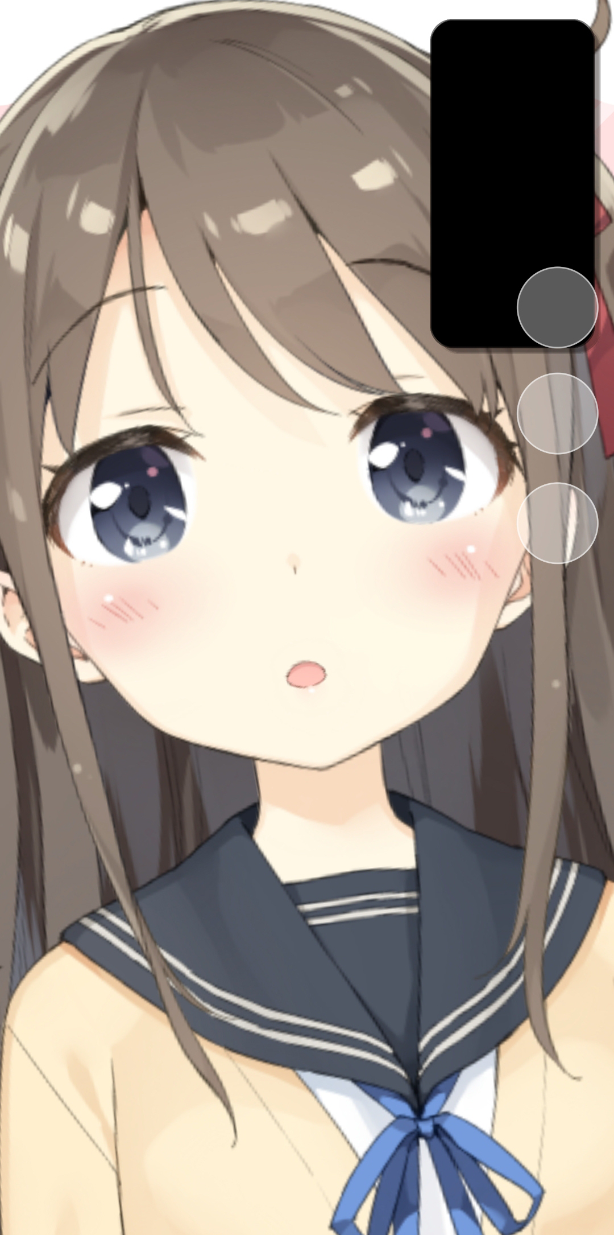

This config tab will let you change settings related to rendering and the camera:

* **AR Camera Config**
  + Change face tracking camera FPS. This does not affect the app framerate.
  + Change whether the camera preview is shown. If you want to make sure your face is never shown on your smartphone screen, you can configure that here (see third picture).
  + Change whether face mask is shown over your face.
* **Tracking Config**
  + Change behavior of model when face tracking is lost. You can either have the model freeze in place when your face is lost or have it return to its default pose.
* **Quality and Effects**
  + Turn on Anti-Aliasing (smoother model edges but costs performance, not recommended on mobile)
  + Change app FPS. VSync means the FPS will be synced to your display update rate. This is recommended on PC to prevent screen-tearing.
* **Record Screen**
  + Smartphone-only. Lets you directly record your screen including microphone sound. A small red dot will be shown at the bottom-right while recording. Tap it to stop the recording at any time.

## VTS Model Setting

### Basic Setup

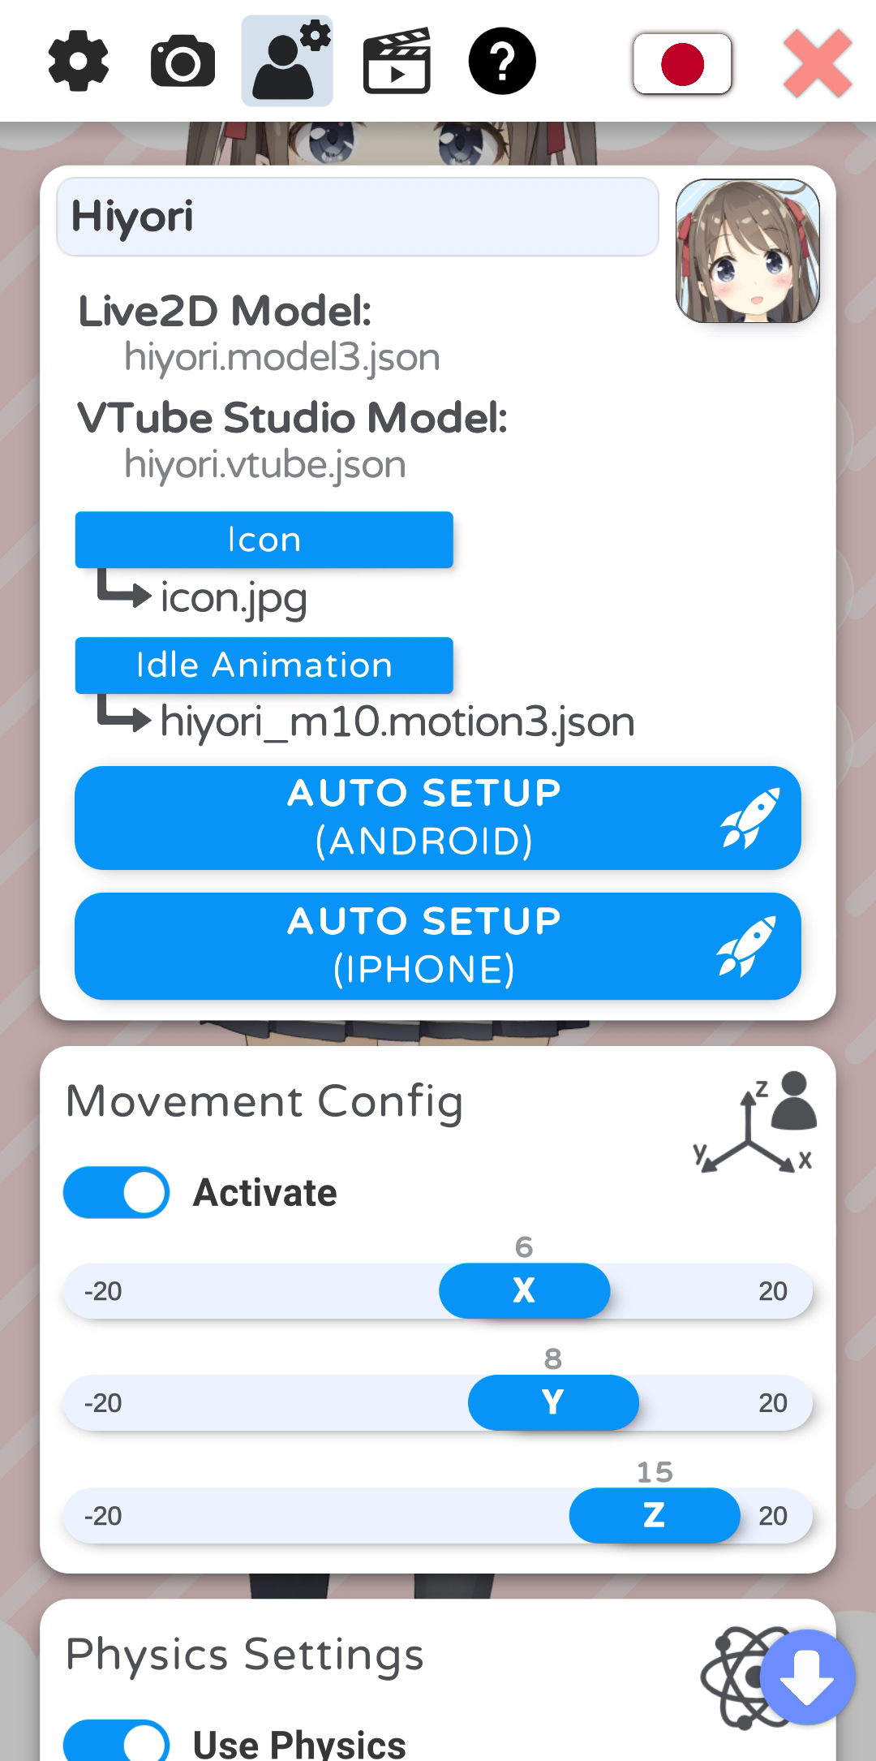 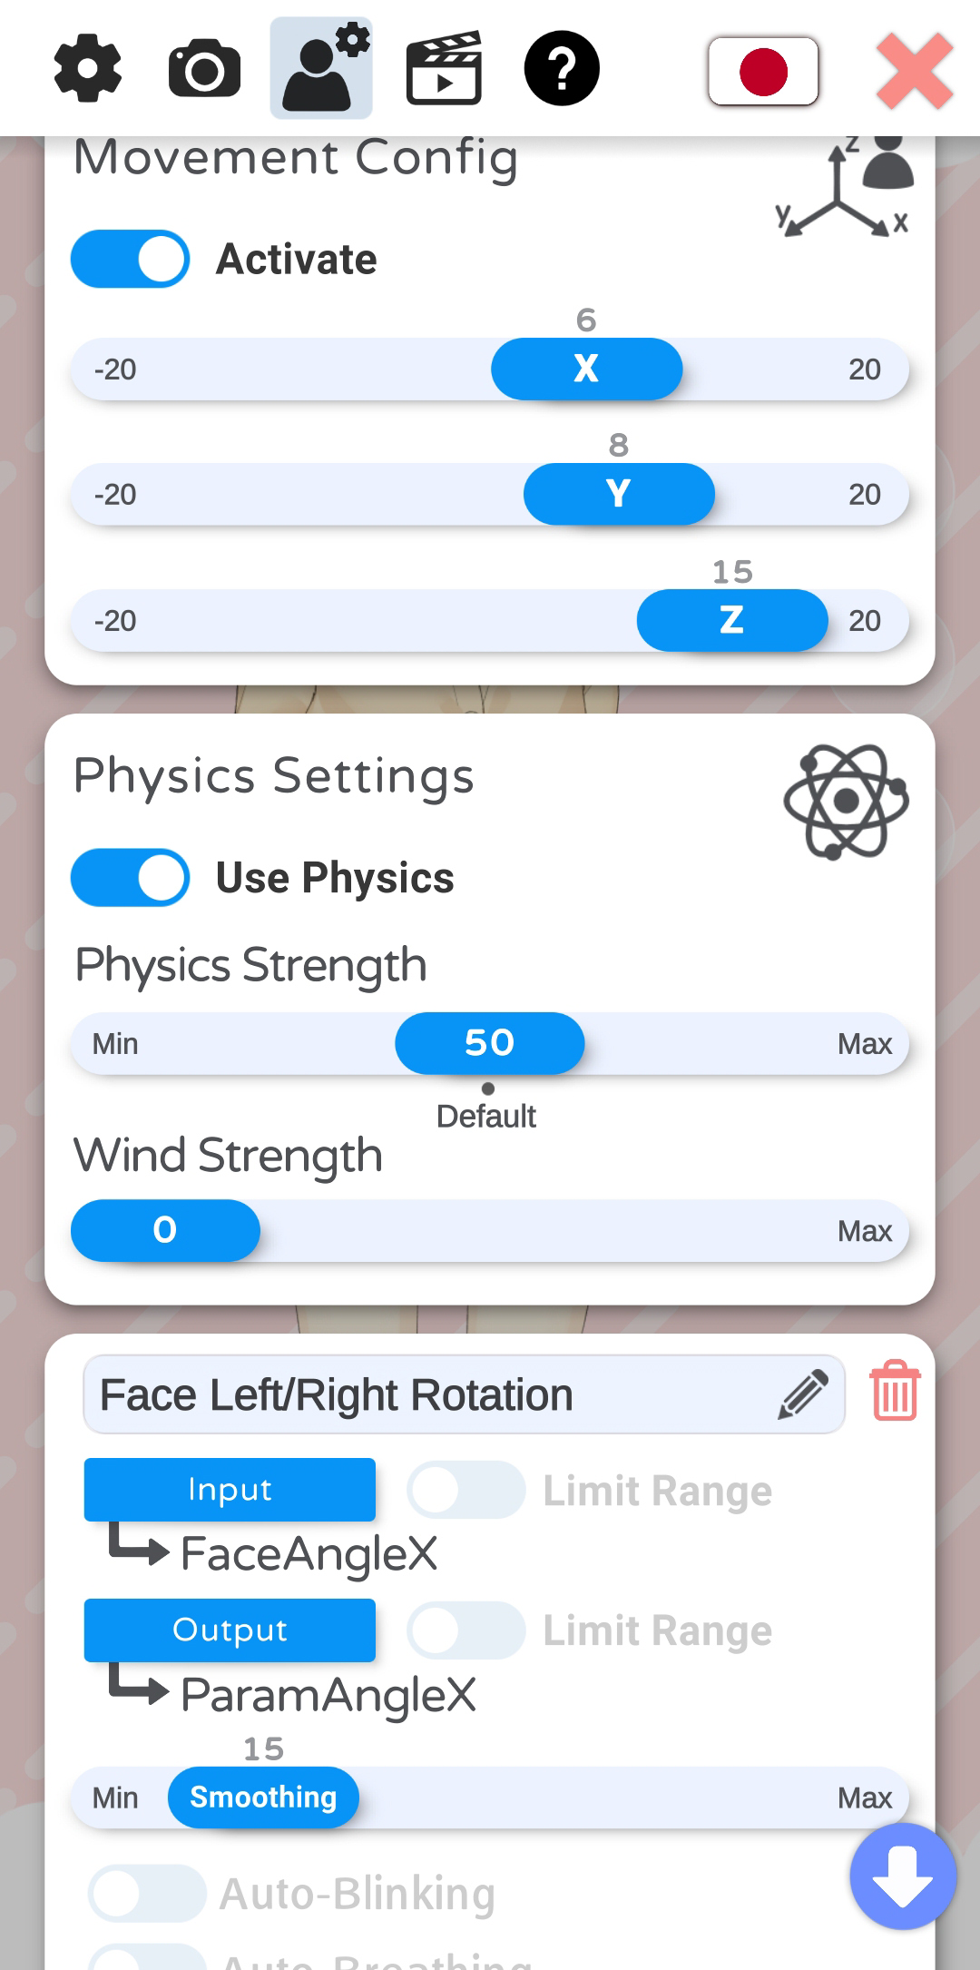 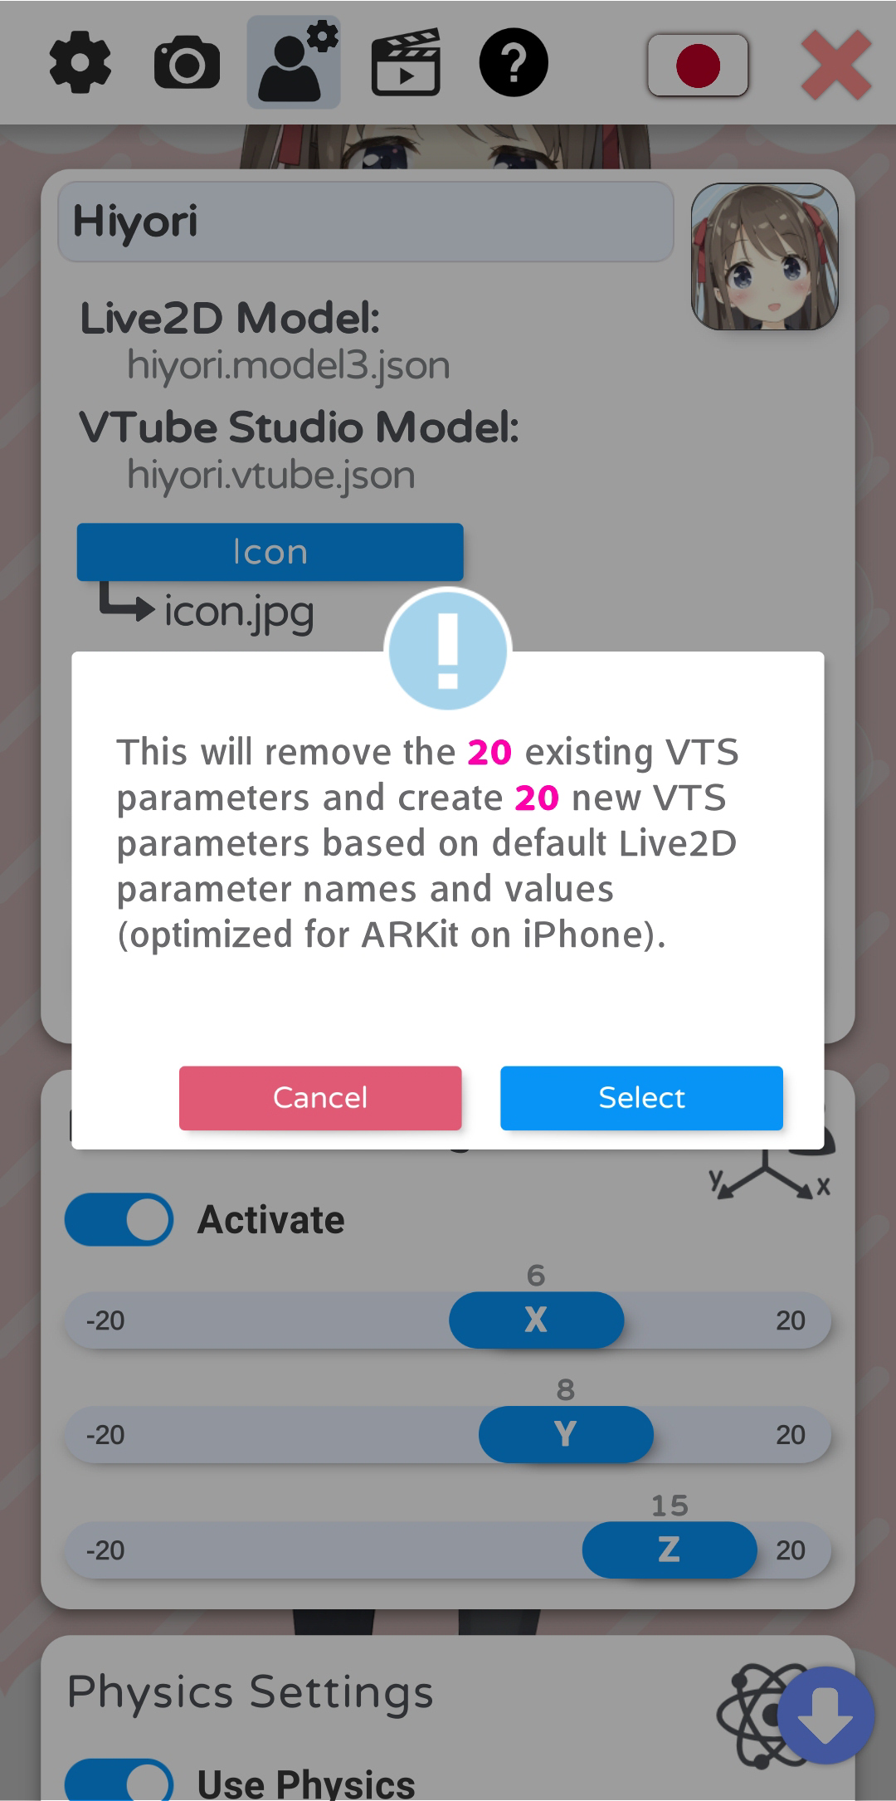

Once you have loaded a model, you will be able to access the model settings in the VTS model config tab.

At the top, you can enter a name for your model. This name will be shown in the model selection bar.

Below that, you can see the name of the Live2D model file and the automatically created VTube Studio model file (VTS model).

You can choose an icon (.jpg or .png) and default idle animation (.motion3.json) for your model. You can choose from any file inside your model folder.

You can also run the auto-setup for your VTube Studio model. This will set up your model based on standard Live2D parameter names and values. For more information about these parameters, please see: [https://docs.live2d.com/cubism-editor-manual/standard-parametor-list/#](https://docs.live2d.com/cubism-editor-manual/standard-parametor-list/)

If you change the parameter IDs or ranges, auto-setup will not be able to set up your model and you’ll have to do it manually. Even if you use auto-setup, you may have to fine-tune your VTS model to fit your Live2D model.

### Model Movement

With the “Model Movement” settings, you can move the model left/right and closer/further away from the screen based on your head position. With the sliders, you can configure how much the model is moved.

### Physics Settings

Here, you can boost or reduce the effect of your Live2D physics setup. You can also activate “wind”, which will randomly apply a wind-like force to the physics system. This is experimental and may not look good depending on how your model is set up.

### VTS Parameter Setup

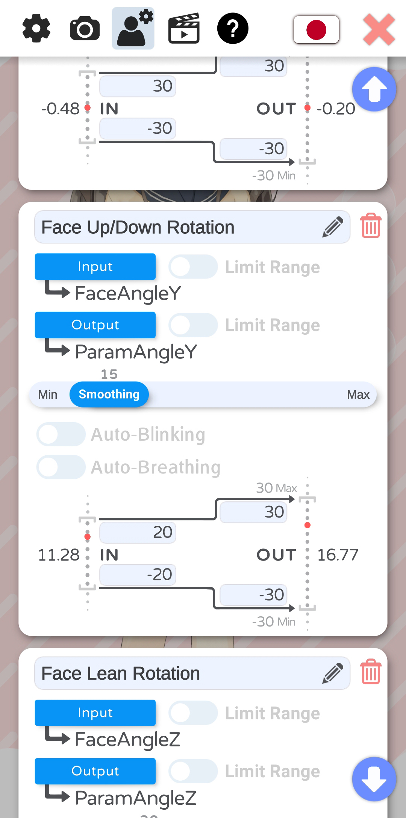 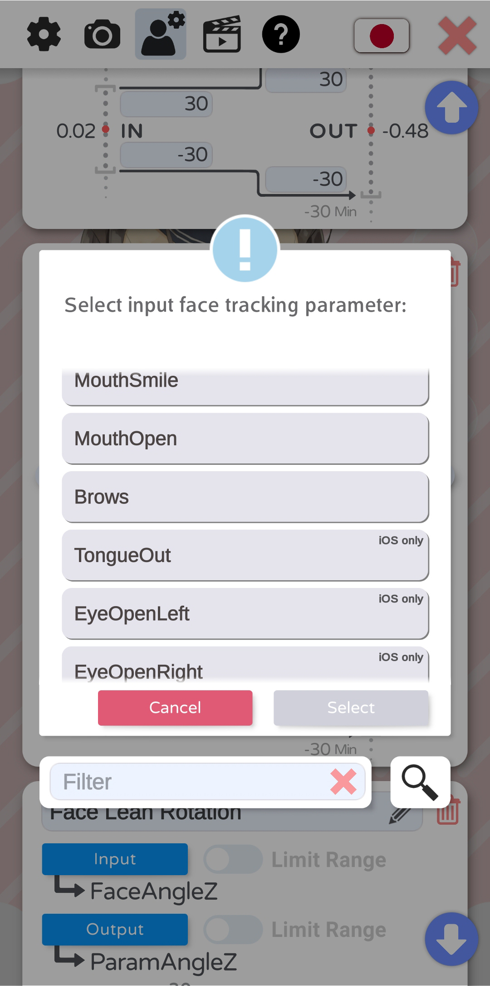 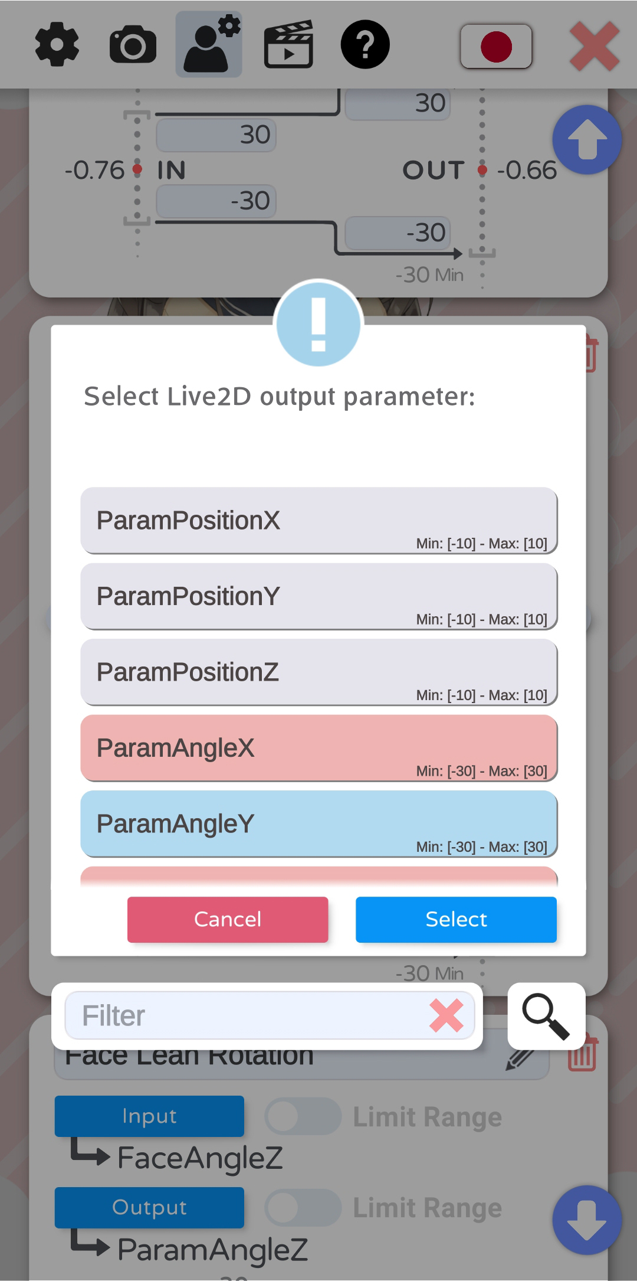

This is the most important part of your model settings. Here, you set up which face tracking parameters control which Live2D parameters.

The general idea is:

* You can freely map any INPUT parameter (face-tracking, mouse, etc.) to any OUTPUT parameter (Live2D parameter).
* How the values are mapped can be freely configured. For example, the input parameter MouthOpen is within the range [0, 1], with 0 being closed and 1 being all the way open. If your Live2D parameter (for example named ParamMouthOpen) has the range [-10, 10], you could map the ranges so (IN, 0) becomes (OUT, -10) and (IN, 1) becomes (OUT, 10). Or you map it any other way, there are no restrictions.
* The red dot will show where the current value is placed within the input and output range.
* By activating “Limit Range”, you can make sure the the input or output values never exceed the range you set for the input or output. This will also cause the value to stop smoothly when approaching the limits.
* Generally, it is recommended to only change the output range and leave the input range as is.
* More smoothing will make the movements less shaky but will introduce lag. Experiment with the smoothing values until you find something that works for each parameter. On iOS, you will most likely need very little smoothing.
* Auto-breath will fade the output parameter up and down in a breath-like motion. No input parameter is required when using this option. Any input will be ignored.
* Auto-blink will randomly reduce the parameter to zero. This can be combined with an input parameter, but none is necessary.
* As input parameter, you can choose from a list of available parameters. iOS supports more face tracking parameters than Android (see below).
* As output parameter, you can choose any Live2D parameter. Each output parameter can only be chosen once, as otherwise you would have multiple input parameters writing to the same output parameter.



If your model doesn’t move despite the Live2D parameter clearly moving in the VTS model

config, the cause is most likely an expression, an animation or the physics system overwriting

the value from the face tracking. This is explained in detail in the chapter:

Interaction between Animations, Expressions, Face Tracking, Physics, etc.

### Supported INPUT parameters (face tracking, etc.)

VTube Studio currently supports the following input parameters that can be mapped to output Live2D parameters. The iOS-only parameters are also marked accordingly in the app.

|  |  |  |  |  |
| --- | --- | --- | --- | --- |
| Parameter Name | Explanation | iOS | Android | Notes |
| FacePositionX | horizontal position of face | ✔️ | ✔️ |  |
| FacePositionY | vertical position of face | ✔️ | ✔️ |  |
| FacePositionZ | distance from camera | ✔️ | ✔️ |  |
| FaceAngleX | face right/left rotation | ✔️ | ✔️ |  |
| FaceAngleY | face up/down rotation | ✔️ | ✔️ |  |
| FaceAngleZ | face lean rotation | ✔️ | ✔️ |  |
| MouthSmile | how much you’re smiling | ✔️ | ✔️ | frown not detected |
| MouthOpen | how open your mouth is | ✔️ | ✔️ |  |
| Brows | up/down for both brows combined | ✔️ | ✔️ |  |
| MousePositionX | x-pos. of mouse or finger within set range | ✔️ | ✔️ |  |
| MousePositionY | y-pos. of mouse or finger within set range | ✔️ | ✔️ |  |
| TongueOut | stick out your tongue | ✔️ | ❌ |  |
| EyeOpenLeft | how open your left eye is | ✔️ | ❌ |  |
| EyeOpenRight | how open your right eye is | ✔️ | ❌ |  |
| EyeLeftX | eye-tracking | ✔️ | ❌ |  |
| EyeLeftY | eye-tracking | ✔️ | ❌ |  |
| EyeRightX | eye-tracking | ✔️ | ❌ |  |
| EyeRightY | eye-tracking | ✔️ | ❌ |  |
| CheekPuff | detects when you puff out your cheeks | ✔️ | ❌ |  |
| BrowLeftY | up/down for left brow | ✔️ | ❌ |  |
| BrowRightY | up/down for right brow | ✔️ | ❌ |  |
| FaceAngry | detects angry face | ✔️ | ❌ | EXPERIMENTAL |

### Hotkey Settings and Types

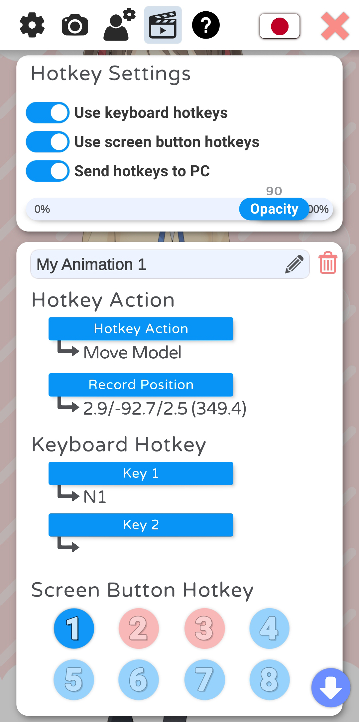 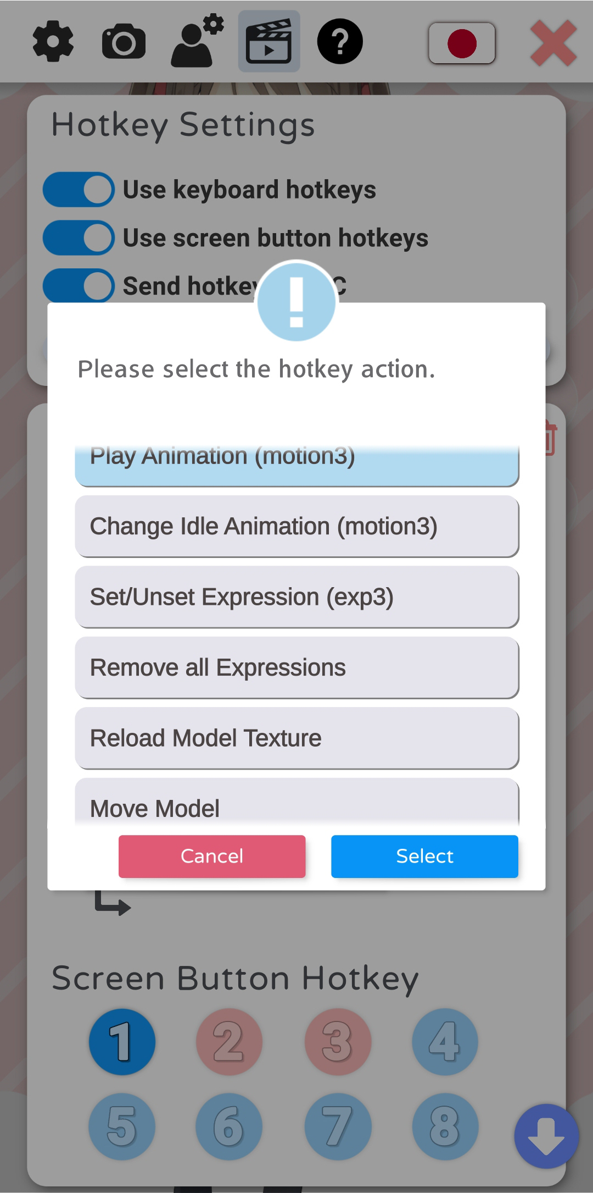 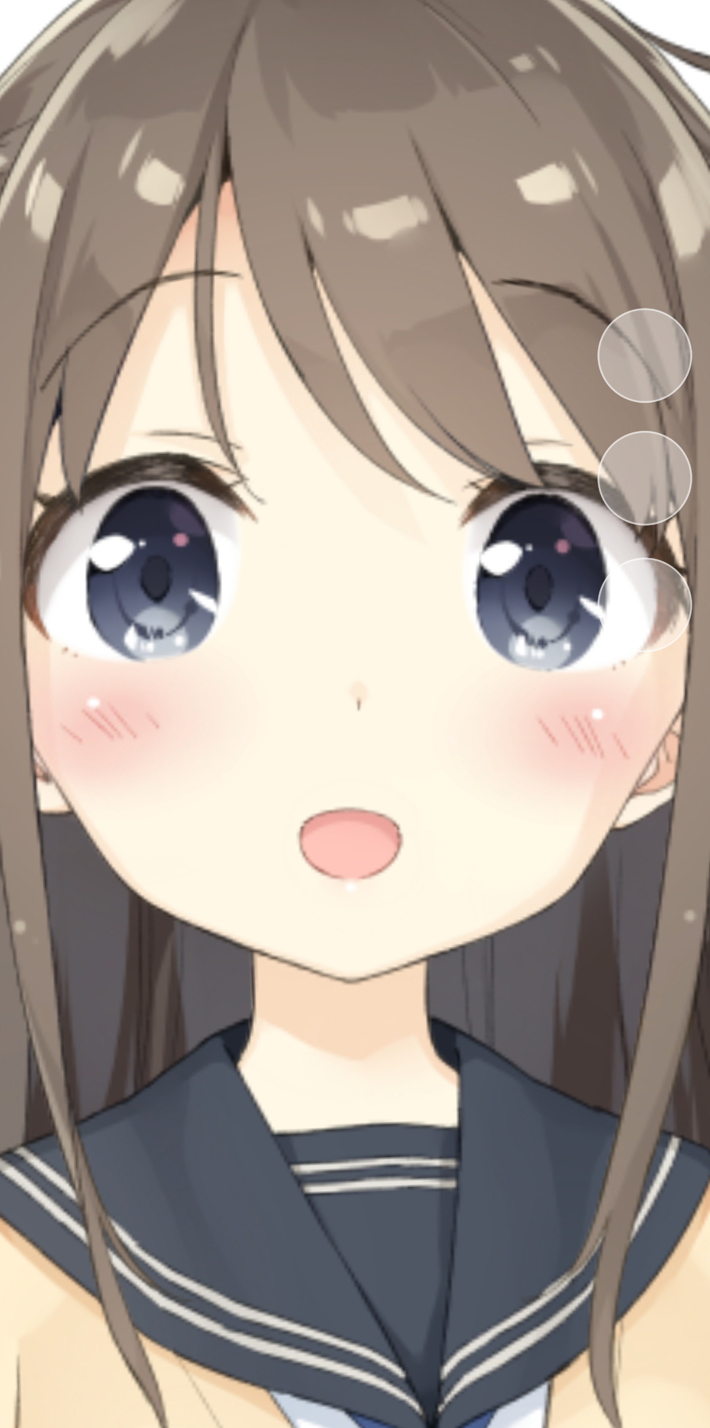

In VTube Studio, you can use hotkeys to trigger various actions. When creating a new hotkey, it is saved in the VTube Studio model configuration file. You can give hotkeys names that are also shown in the logs when the hotkey is activated.

There are two ways to trigger hotkeys:

* **Keyboard-Hotkeys (PC/Mac only)**
  + As the name implies, you can trigger hotkeys by pressing keys on your keyboard.
  + You can set combinations of up to 2 keys.
  + Keypresses are also read when the VTube Studio window is not in focus, for example when you’re playing a game. However, this does not work on macOS.
  + Also included: Mouse-Hotkeys (right/left/middle click).

* **On-Screen Button Hotkeys (PC/Mac and smartphones)**
  + Up to 8 hotkeys can be set as on-screen buttons. They will be shown as semi-transparent white circles on the right of the main screen (see picture 3).
  + Opacity can be changed. They can also be made invisible.
  + If you activate **“Send hotkeys to PC”**, pressing an on-screen hotkey on your smartphone will send a signal to your PC (if connected) that the key with that ID has been pressed. When the model you have loaded on your PC also has on-screen button hotkeys set up, the corresponding key will be triggered.
  + You do not need to have a model loaded on your smartphone to send hotkey presses to your PC. If no model is loaded, all 8 on-screen buttons will be shown.

### Hotkey Actions

Various actions can be triggered by hotkeys:

* **Play Animation (.motion3.json)**
  + Will play the given animation once (overwrites face tracking)
* **Change Idle Animation (.motion3.json)**
  + Will change the currently looping idle animation. Will not be saved into the VTS model configuration.
* **Set/Unset Expression (.exp3.json)**
  + Toggles the given expression in the model (overwrites face tracking and animations)
  + If multiple expressions set the same Live2D parameter to different values, the last expression will decide the value.
  + More on this in the chapter “Expressions”
* **Remove all Expressions**
  + Removes all currently set expressions.
* **Reload Model Texture**
  + Reloads the model texture. This means you can modify your model .PNG-texture outside the app and reload it on the fly. Can be used for various cool effects during streams.
* **Move Model**
  + Moves the model to the given position/rotation/size.
  + The position for the hotkey can be set using the “Record Position” button, which will save the current model position, rotation and size. The numbers shown are:
    - x-pos/y-pos/size rotation

# Expressions (a.k.a. „Stickers“ or „Emotes“)

Expressions are created using the **Live2D Cubism Viewer**. You can download it for free as part of the Live2D Cubism Editor: <https://www.live2d.com/en/download/>

Expressions allow you to set Live2D parameters to certain values using hotkeys. Using expressions, you can for example trigger different facial expressions or costume changes.

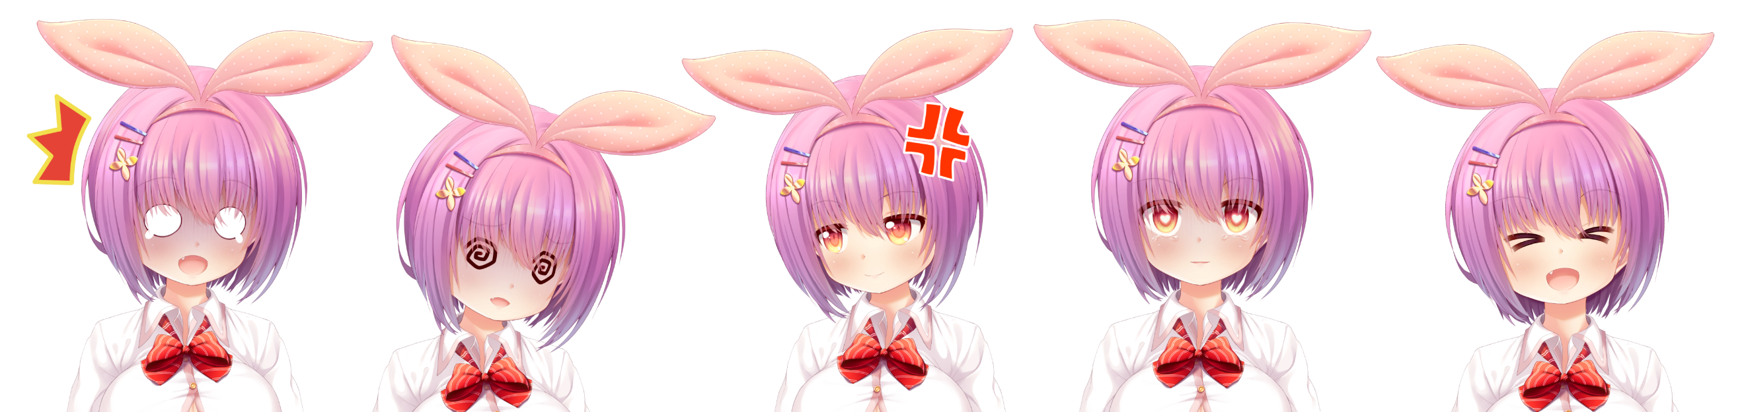

To create expressions, first load your model into the Live2D Cubism Viewer by dragging in the  
.model3.json file. Your model should now be open and ready to edit.

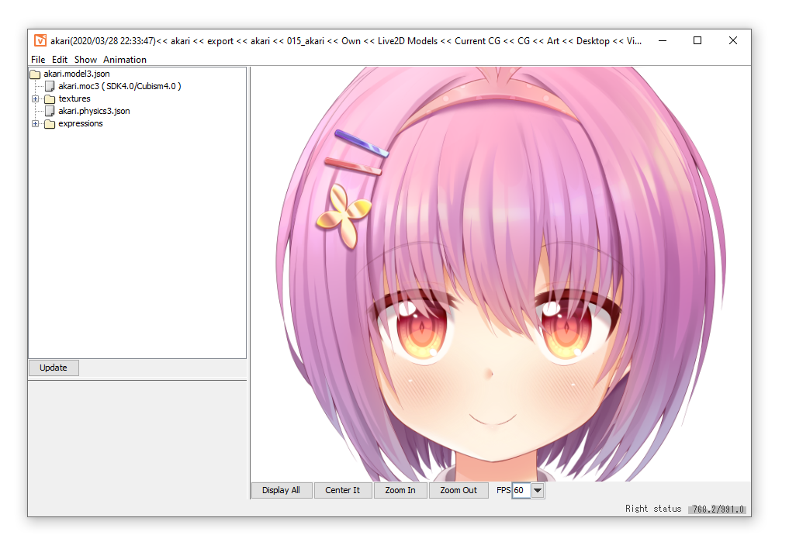

To create a new expression, you can now do the following:

1. Add a new expression using **File 🡪 Add 🡪 Expression**
2. Make sure **Animation 🡪 Apply Expression** is activated.
3. There should now be a folder called “Expressions” in the navigation window. Open it and click your newly created .exp3.json file.
4. Create your expression by adjusting the sliders and checkboxes for the parameters you want to be part of the expression.
5. Fade-times are ignored by VTube Studio in the current version. Instead, a default fade-time is used.
6. You can also right-click a parameter and set it to “Multiply”. This is not yet supported by VTube Studio and may result in your expressions not working. Please leave it at “Additive”.
7. To save the expression, right-click your .exp3.json file and select “Save”. Save it somewhere next to your VTS/Live2D model or in any subfolder of that folder so VTS can find it when your model is loaded.

To set up the expressions in VTube Studio:

1. Create a new hotkey inside of VTube Studio as explained in the chapters about hotkeys.
2. Use the hotkey type “Set/Unset Expression”
3. Select your newly created expression from the list. If you can’t find it there, make sure the .exp3.json file is in the same folder as your VTS model file or in a subfolder of it.
4. Your hotkey is now fully set up. You can use either your keyboard or the on-screen buttons to activate and deactivate it.



When multiple hotkeys modify the same Live2D parameter, the value of the last activated

hotkey is used. When you then deactivate the “last” hotkey, the value is returned to the value

of the “previous” hotkey. When all hotkeys that modify a certain Live2D parameter are

deactivated, that parameter is returned to the value from the animation, the value from face

tracking or the default value. More on this in the chapter:

Interaction between Animations, Expressions, Face Tracking, Physics, etc.

# Animations

Animations can be created with the Animator in the Live2D Cubism Editor. Once your animation is done, select **File 🡪 Export for Runtime 🡪 Export motion file**.

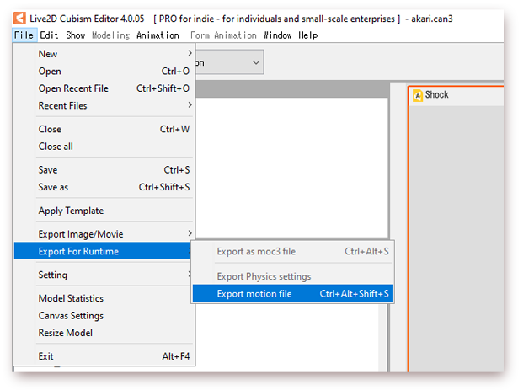

This will give you .motion3.json files (Live2D animation files) that can be read by VTube Studio. Put them in the same folder as your VTS model or a subfolder.

These animations can be used as looping background idle animation or one-shot animation.

# Interaction between Animations, Expressions, Face Tracking, Physics, etc.

In VTube Studio, Live2D parameters can be controlled by various entities, such as Live2D Animations, face tracking or Live2D Expressions. But what happens when animations, face tracking and expressions try to write to the same Live2D parameter at the same time? That is explained in this chapter.

In VTube Studio, each Live2D parameter can be controlled by one of six “value-providers”. In order of priority (lowest to highest), they are:

|  |  |  |
| --- | --- | --- |
| Priority | Value-Provider | Notes |
| P0 | Default Live2D parameter value | Available for every Live2D parameter |
| P1 | Value from Idle Animation |  |
| P2 | Value from Face Tracking |  |
| P3 | Value from One-Time Animation | As long as animation is active |
| P4 | Value from Live2D Expression | As long as expression is active |
| P5 | Value from Physics System |  |

The final value of an individual Live2D parameter in your model will be determined by the highest-priority active value provider. For example, when a Live2D parameter called ParamA has a one-time animation (triggered by hotkey) writing to it, any values from the face tracking or idle animation are overwritten.

Once the one-time animation ends, control will be passed back to the active value-provider with the next highest priority.

Specifically, this means that the face tracking would now control ParamA if ParamA is set as an output parameter in your VTS model config. If not, ParamA will now be controlled by the idle animation. Or, if the idle animation also does not contain ParamA, it will be set to its default value, which every Live2D parameter has.

When control of a Live2D parameter is passed between value-providers, it is always faded smoothly and not just set instantly to prevent any ugly jumps.

# Streaming to Mac/PC

The main use-case of VTube Studio is to use your smartphone for face tracking, render your model in the Mac/PC app and then use OBS (or recording similar software) to stream to YouTube or Twitch. Any Windows/Mac recording software should work with VTube Studio.



VTube Studio uses your local network (TCP/UDP) to send face tracking data from your

smartphone to your PC or Mac. Depending on your home network setup, there may be

connection issues, most frequently caused by your firewall configuration. For more info,

check out the chapter:

Connection Issues & Troubleshooting

## Preparation on PC/Mac

Streaming the face tracking data from your smartphone to PC/Mac is easy. First, make sure both your smartphone and PC/Mac are on the same local network, otherwise they will not be able to see each other.

Then, start the desktop app. In the settings, you can activate the server after choosing a port (try leaving the default port first, 25565).

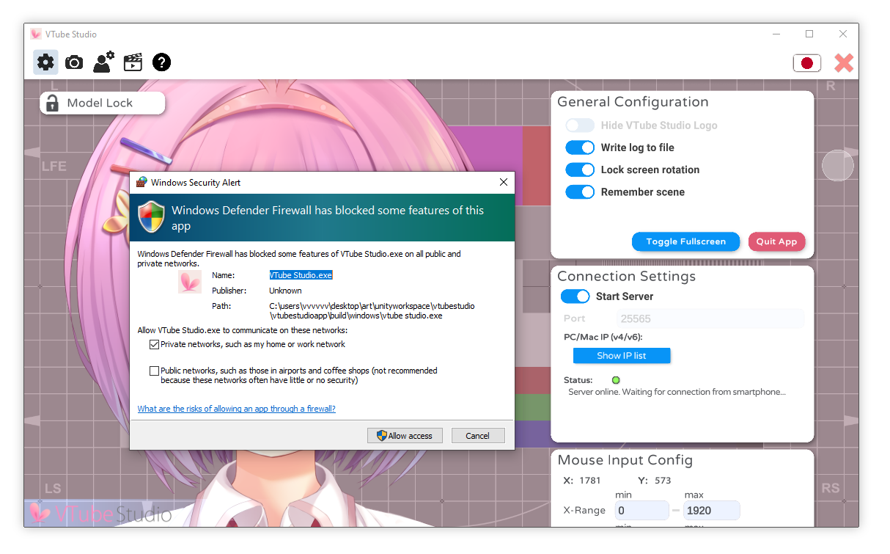

This will start the VTube Studio server on your PC on every available network device. Since your PC may have multiple network devices, you may see multiple IPs when clicking the **“Show IP list”** button.

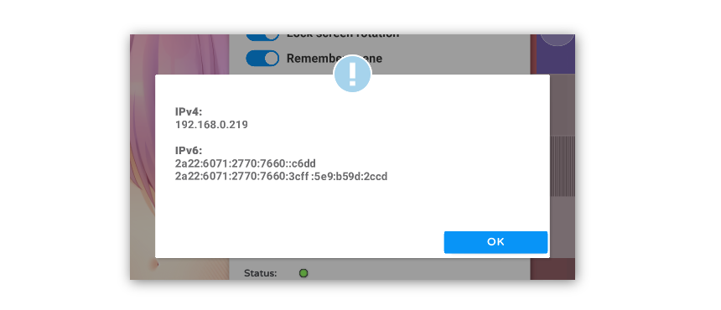



While your IPv4 shown here is typically a local, internal address and cannot be publicly

accessed over the internet, your IPv6 addresses are likely to be public addresses!

Please be careful to block them out if you post screenshots on the internet. Stay safe!

When starting the server for the first time, you may see a popup from the Windows Defender Firewall. Make sure you click “Allow access” and “Private networks” is checked. Otherwise, your smartphone will not be able to connect to the PC app as connections will be blocked by the firewall.

The server is now active and is listening for connections from the smartphone app. Leave it this way.

## Connecting the Smartphone App

Next, start the app on your smartphone. In the settings, you can manually type in the IP and port from the desktop application or use the **“Find Server”** button to automatically scan for the server and use its IP and port. This scan should not take longer than 5 seconds.

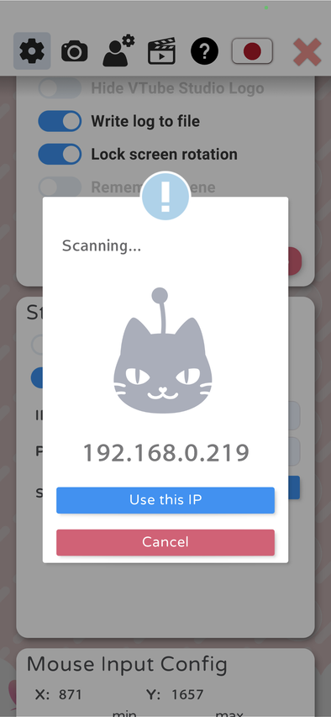 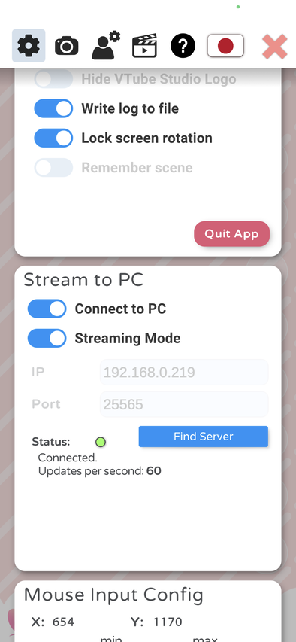 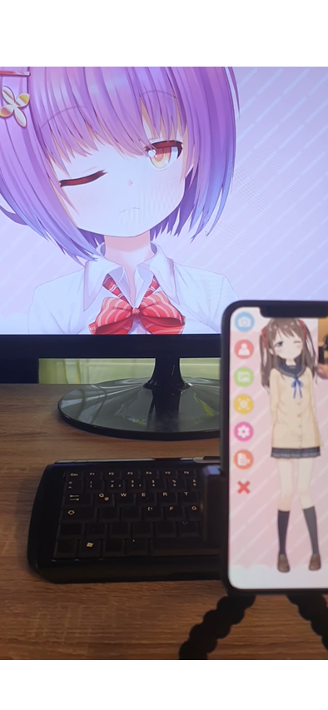

Now, click “Connect to PC”. The app will now connect to the server. If the connection is lost for some reason, the app will try to re-establish the connection automatically.

**Congratulations.** You are now streaming your face tracking data to your PC. You can now open a VTS model in the desktop application and it will use the face tracking data from the smartphone. You can also have the same or a different model open in the smartphone app at the same time if you’d like.



You do not need to have a model open on your smartphone when streaming to PC. In fact, it is

recommended to not have one open for performance reasons. When using “Streaming Mode”,

any opened models on your smartphone will be automatically unloaded when connecting.

## Recording with OBS (transparent background)

On your PC in VTube Studio, choose the **Color Picker background**. On Windows, you can use the “Transparent in capture” option here, which will make the window background transparent when the window is recorded in OBS **so you don’t need to use greenscreen/chroma keying**.

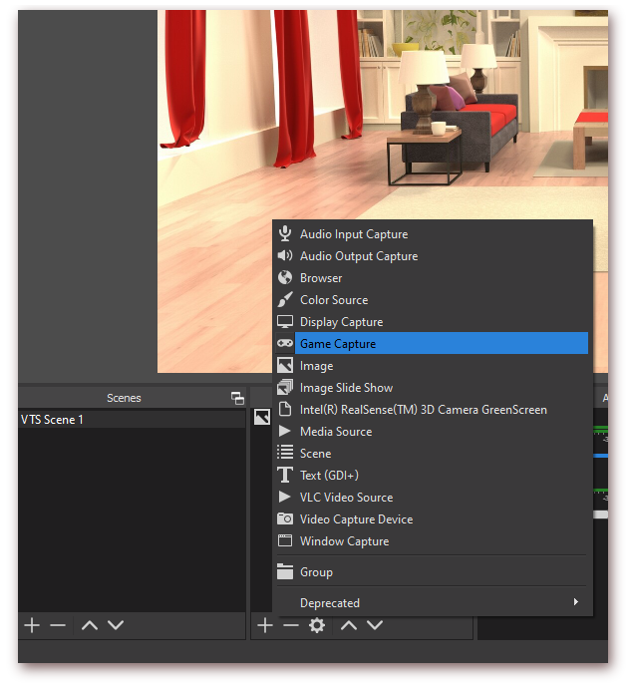

**On macOS, this feature is not supported by OBS**, so choose any color you want here. You can remove that color from the video capture in OBS using a **“Chroma Key”** filter. Keep in mind that you can’t use that color in your Live2D model, otherwise some parts of your model may be transparent as well.

Add a background in OBS, then add a capture for VTube Studio. To do that, select **“Game Capture”**. This supports transparent backgrounds but is only available on Windows.

On macOS, this option is called **“Syphon Client”**, but does not work after macOS 10.14 Mojave (see <https://github.com/zakk4223/SyphonInject>), so you need to use a regular window capture and a chroma key filter.

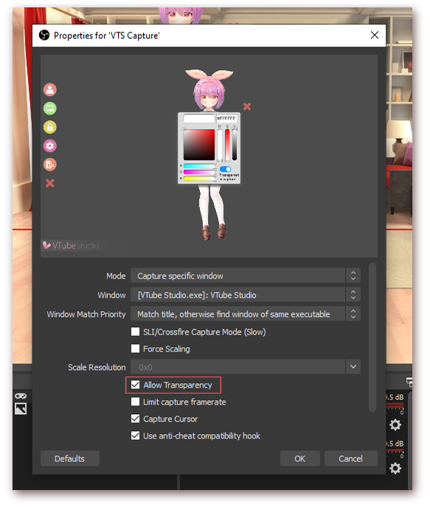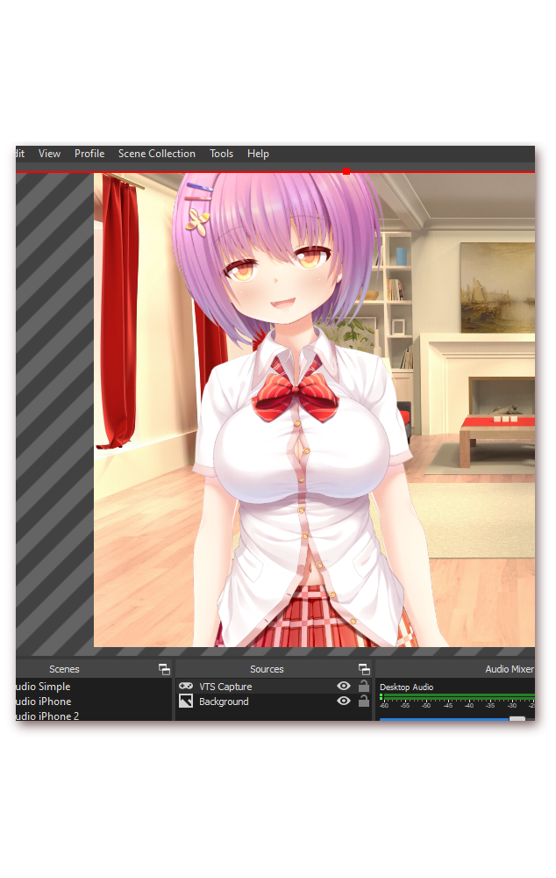

Your capture is now active. On macOS, you need to add a filter to remove the green (or whatever color you selected) background using **Right Click your capture -> Filters -> Add Filter -> Chroma Key.**

You can now place your character anywhere on screen by moving/scaling/rotating it in directly in VTube Studio or in OBS.

Alternatively, you can use the **Virtual Webcam feature** or **NDI** in VTube Studio to create a webcam stream and then directly use that in apps like Zoom, Discord, etc. (see FAQ).

## Using NDI for streaming to OBS with invisible UI (transparent background)

It is recommended to use OBS “Game Capture” to record the VTS window. Alternatively, you can use the Virtual Webcam or [Newtek NDI (Network Device Interface)](https://en.wikipedia.org/wiki/Network_Device_Interface) to create a video stream that can be used as input for software such as OBS.

The quality and latency of NDI streams is very good. It also supports a transparent background (no chroma/color key needed) and does not record the VTube Studio UI at all. CPU utilization of VTS may increase when using NDI. OBS plugins exist for macOS and Windows

**OBS Plugin Page:** <https://obsproject.com/forum/resources/obs-ndi-newtek-ndi%E2%84%A2-integration-into-obs-studio.528/>

**OBS Plugin Download (Win/Mac):** <https://github.com/Palakis/obs-ndi/releases/tag/4.9.1>

To use NDI, download the plugin from the GitHub-page linked above (.exe for Windows, .pkg for macOS) and install it. In VTube Studio, **activate the NDI toggle** in the **“Camera Settings” tab**. It is possible but not recommended to have NDI and the Virtual Webcam active at the same time.

In OBS, the following settings are recommended. Sometimes the NDI streams seems distorted in OBS. If that happens, resize (per drag) the stream until it “snaps back” to looking normal.

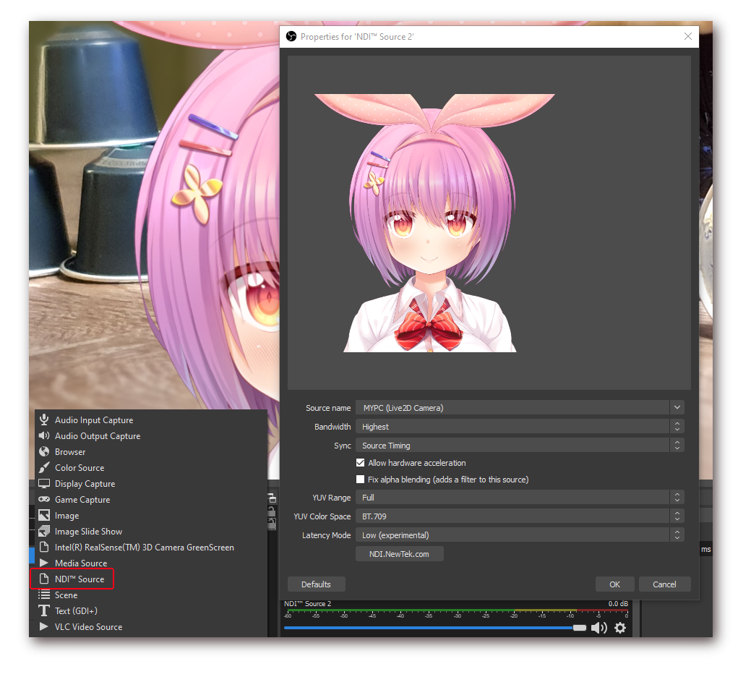

# Connection Issues & Troubleshooting

Under normal circumstances, there should be no connection issues. There also should be no delay and no lag or hiccups/spikes. The streaming should be smooth and should have at most around 10 milliseconds of delay.

However, depending on your local network setup, there might be some issues. This chapter discusses possible causes and solutions.

## Possible Causes for Connection Issues

If you have trouble connecting your smartphone to the PC app (smartphone app is constantly stuck on “Connecting…” or server scan doesn’t find anything), please work through the following list before asking questions on the [Discord](https://discord.gg/RdaqJdu).

* Make sure there is no firewall blocking the connection**. In 90% of cases, this is what causes the connection problems.**
  + To test this, try temporarily turning off your built-in firewall (Windows Defender) and any additional network security software you have. If this fixes the issue, turn them back on and find out how you can add exceptions for VTube Studio (“VtubeStudio.exe”). For Windows Defender, see the image below.
  + After downloading updates for the PC app, you may have to re-add it to the firewall exceptions.
* Make sure both devices (PC/Mac and smartphone) are on the same network.
  + This means both should be on the same WiFi. If the PC and/or smartphone are connected to your router via cable, that is fine too.
  + If your router has multiple WiFi networks available, make sure it is the same for your PC and smartphone. Also, try both networks.
* On Windows, make sure the used network is set to “Private” (see image below).
* Try turning off your Anti-Virus software temporarily.
* Check your router settings. Sometimes there are privacy settings activated that prevent devices from discovering each other.
* If your smartphone can’t see your PC at all, there are issues with your network setup that you’ll need to fix before VTube Studio can work. To test this, use a network discovery / “ping” app and let them run a discovery on your network.
  + Just search for “Network Scanner” on the respective smartphone app store. Any of those apps should work.
  + If you run into specific issues, try to Google them first before asking on Discord.

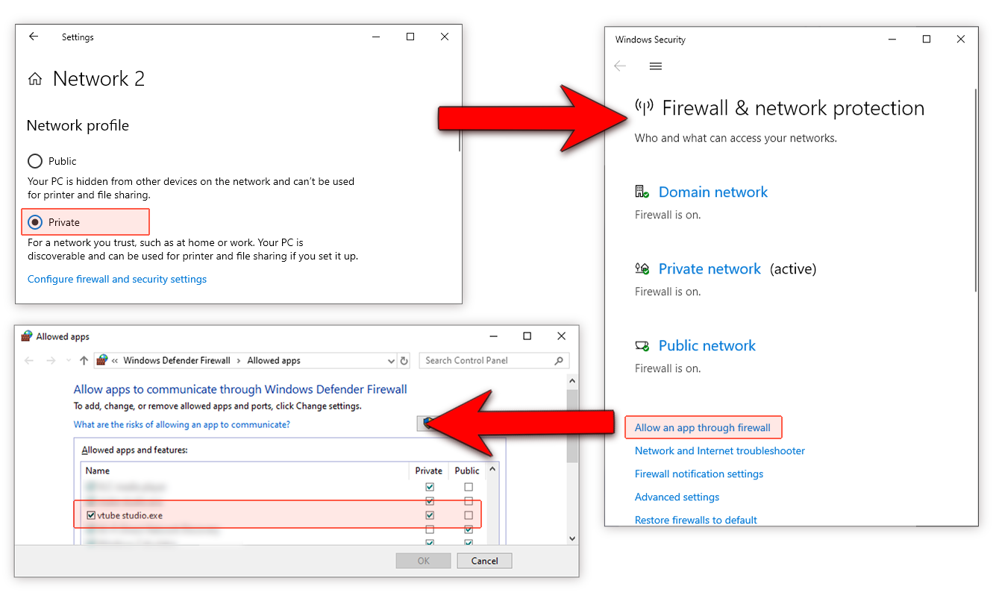

## Network Lag Troubleshooting (general)

If you experience lag or short breaks/freezes when streaming to PC, work through the following list:

* First, try restarting your router. That sometimes helps.
* Are you on WiFi?
  + In some extreme cases, your WiFi reception may cause lag or even very long (multiple seconds) delays in packets being sent over your network. Make sure you use 5GHz WiFi and not 2.4 as depending on your environment, 2.4 Ghz WiFi can have wildly unstable latency.
  + With WiFi, the latency still shouldn’t be higher than 10 milliseconds.
* If possible, use wired LAN connection instead of WiFi. This will give you a lag-free, 1-ms latency connection. You can use wired LAN on your smartphone using an adapter such as [this one for Android (USB-C)](https://www.amazon.com/dp/B0823CB5MT/ref=cm_sw_r_tw_dp_U_x_tE-VEbHCNDE1B) or [this one for iPhone](https://www.amazon.com/dp/B07TNDBB2X/ref=cm_sw_r_tw_dp_U_x_4C-VEb5BWZ0KC).
* Try changing the WiFi-channel that your router uses. When there are routers nearby sending on the same channel, this will cause lag/packet drop issues.
* If nothing helps, try out “ping” / “network analyzer” apps from your smartphone app store to analyze the network connection between your smartphone and PC. This often helps you understand when/why the freezes occur.

## Network Lag Troubleshooting (macOS and iPhone)

If you are on macOS and iOS, there might be some other causes:

* Turn off location services, they will cause lag spikes periodically when your Mac scans your environment for WiFi networks. To turn that off, follow [this guide](https://osxdaily.com/2018/08/20/disable-location-services-mac/).
  + <https://osxdaily.com/2018/08/20/disable-location-services-mac/>
* If you’re using WiFi, remove all unused WiFi-Networks from your list of known networks on both iPhone and Mac to stop them from scanning for them constantly. You can follow [this guide](https://9to5mac.com/2018/07/20/mac-how-to-forget-wireless-networks/).
  + <https://9to5mac.com/2018/07/20/mac-how-to-forget-wireless-networks/>
* When using iPhone and MacBook on WiFi: **Very important to turn off AirDrop on the Macbook**, because it **WILL** cause massive lag spikes when the iPhone is close to the Mac. Open a console and type:
  + **sudo ifconfig awdl0 down**
* Later, when you’re done streaming, you can turn it back on by rebooting your Mac or typing this in a console:
  + **sudo ifconfig awdl0 up**
* Turning off Bluetooth on your Mac and iPhone can also help. You can follow [this guide](https://support.apple.com/guide/mac-help/turn-bluetooth-on-or-off-blth1008/mac) to turn of Bluetooth on your Mac.
  + <https://support.apple.com/guide/mac-help/turn-bluetooth-on-or-off-blth1008/mac>

# Taking/Sharing Screenshots

With VTube Studio, you can **take screenshots** directly from within the app, **save them and share them on social media**. Screenshots are saved as .PNG file. You can also turn the background transparent so only your model and any items in the scene are visible in the screenshot

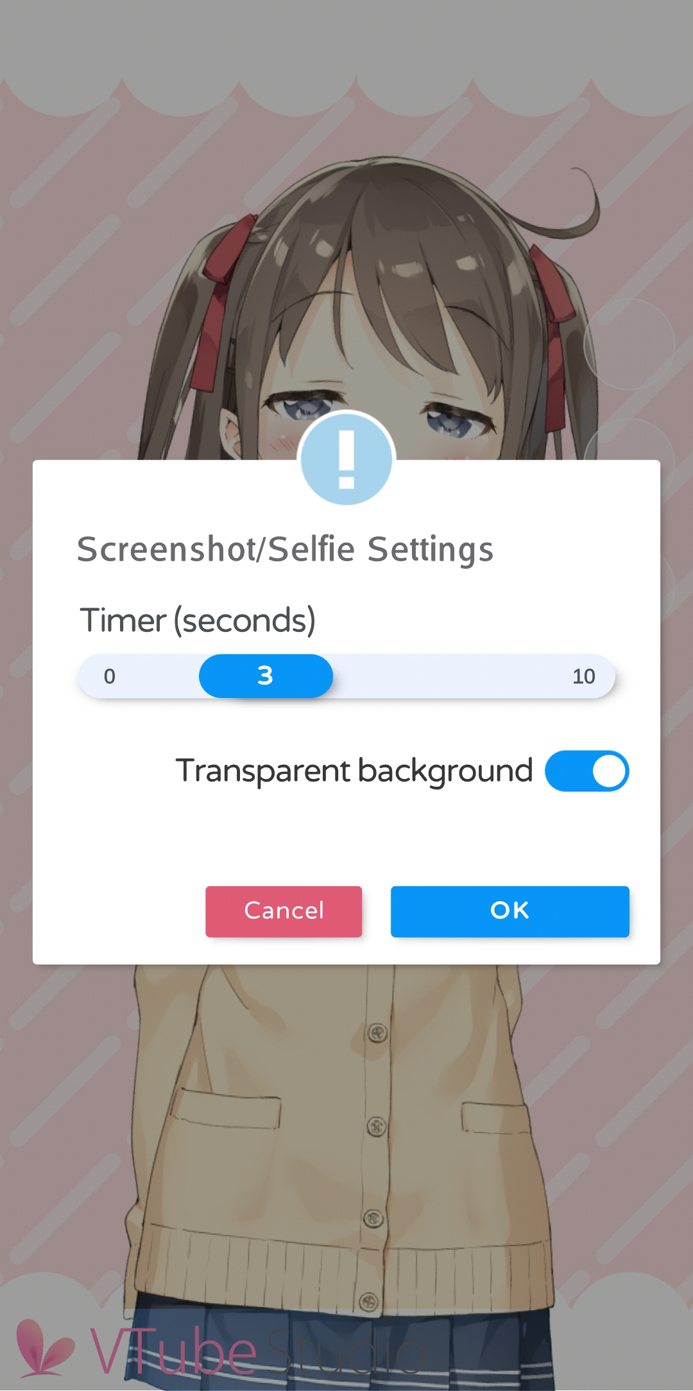 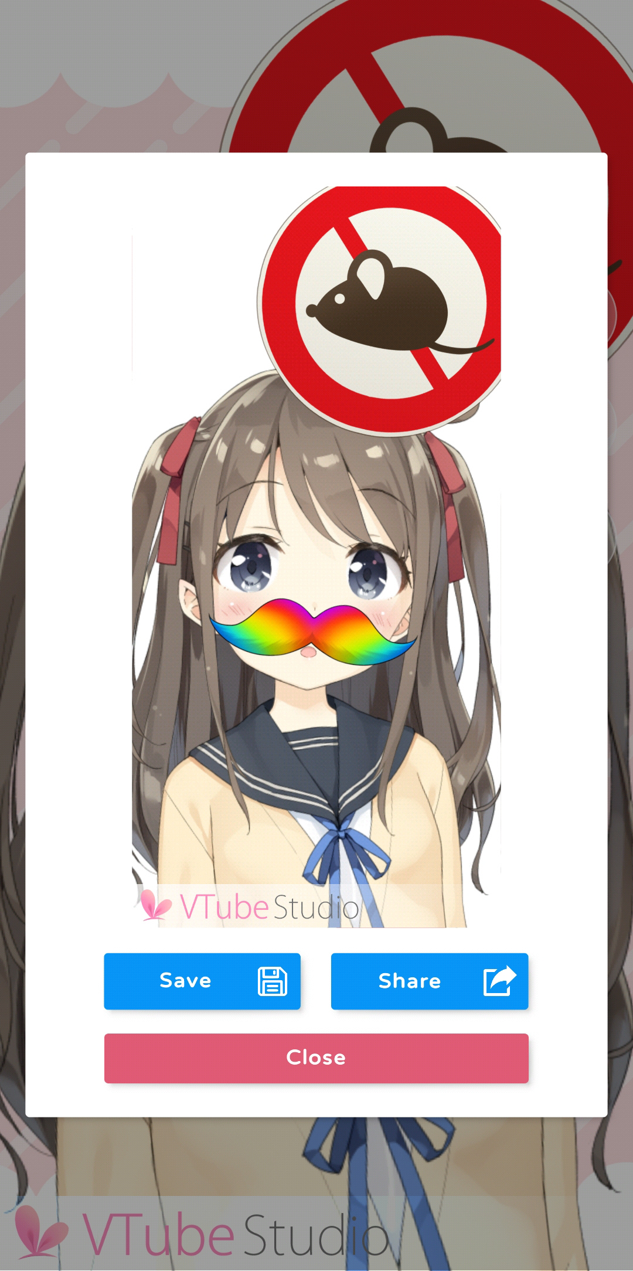.

On Windows and MacOS, screenshots are saved to your user’s “Pictures” folder. On smartphones, screenshots are saved directly to the phone gallery. The app will ask for permission to use this folder.

Screenshots with transparent background are really useful for producing PNGs of your model that you can for example use in video/stream thumbnails.

On smartphones, you can also directly share your screenshots on Twitter, Discord, etc.

# Item System

Starting with VTube Studio version 1.5.0, you can import your own props (“items”) directly into the scene and even attach them to your Live2D model.

Items are read from the **“Items” folder next to your “Live2DModels” folder**. VTube Studio comes with a few items included, but you can add your own by putting PNGs into that folder.

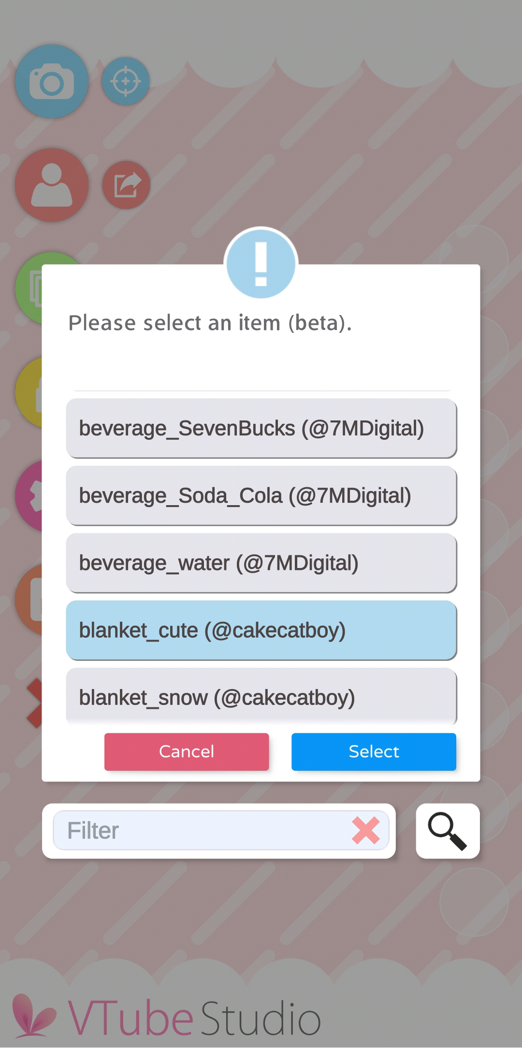 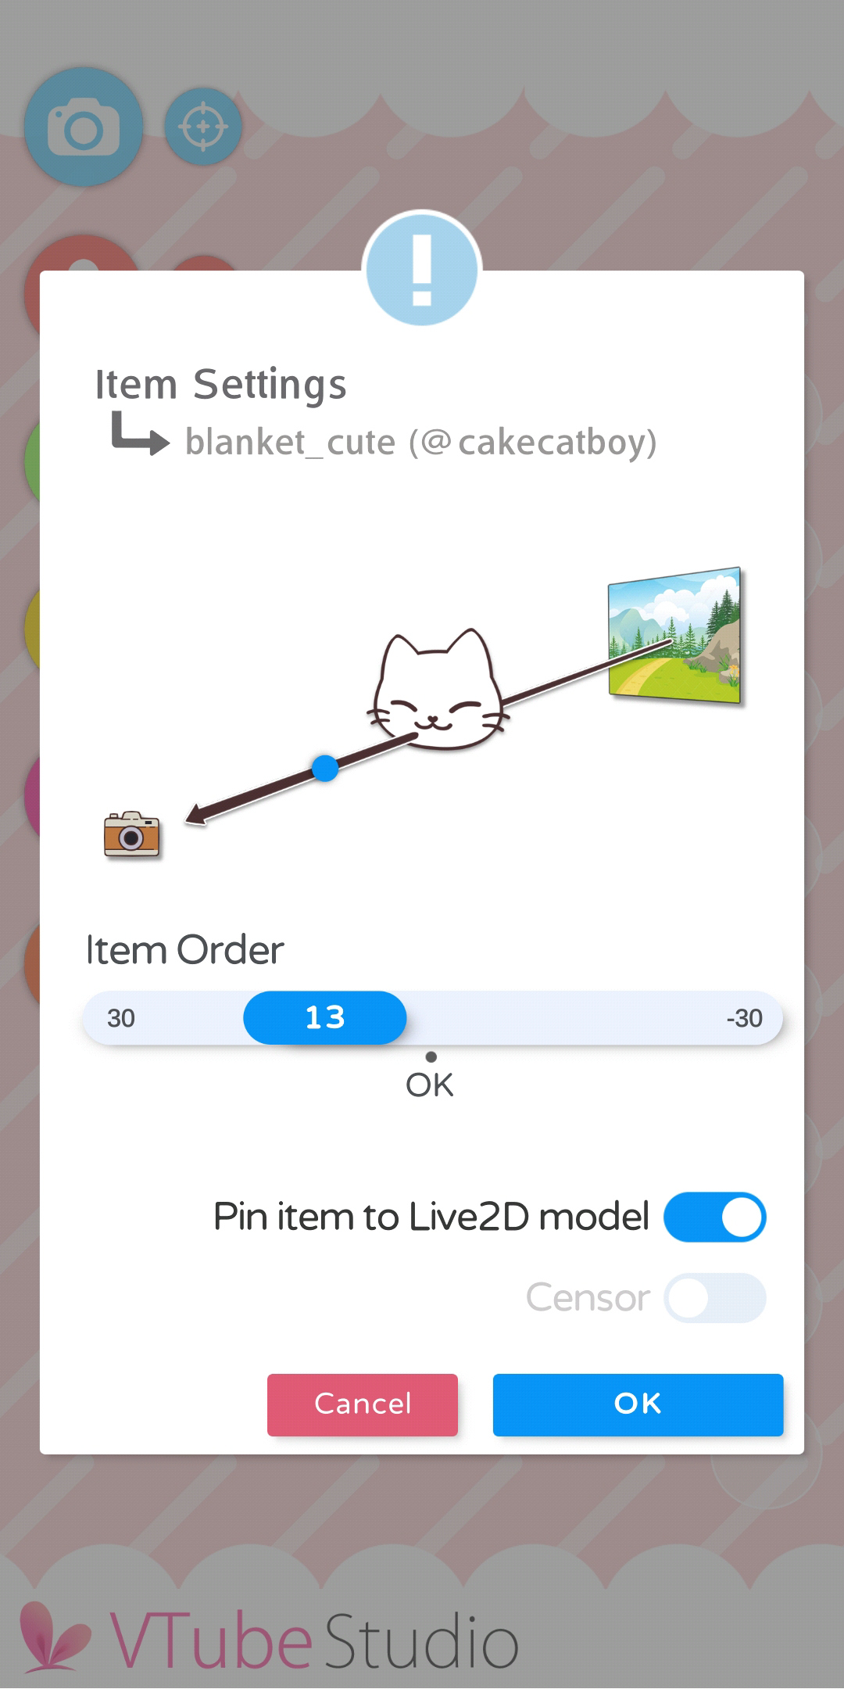.

First, choose the item you’d like to add. Then choose an order. Items with a higher order are in front of items with a lower order. The Live2D model itself is at order 0, so you can also place items behind it.

If you want the item to be able to attach to the Live2D model, make sure to select **“Pin item to Live2D model”**

There is an experimental **“Censor”** option that applies a mosaic censor effect to the item.

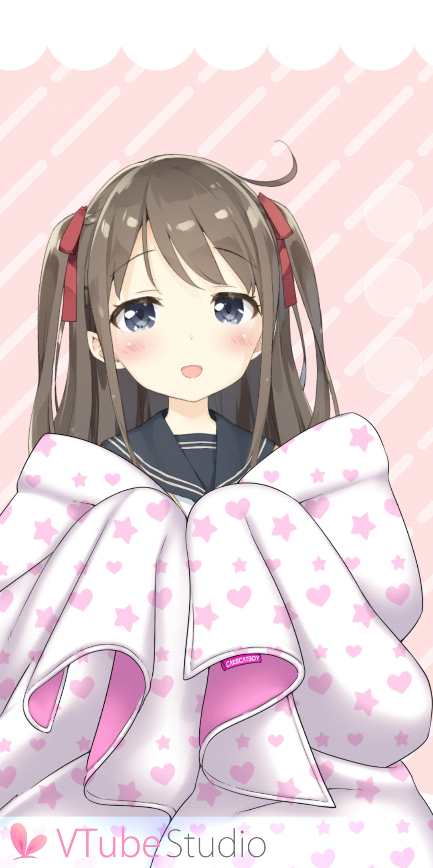 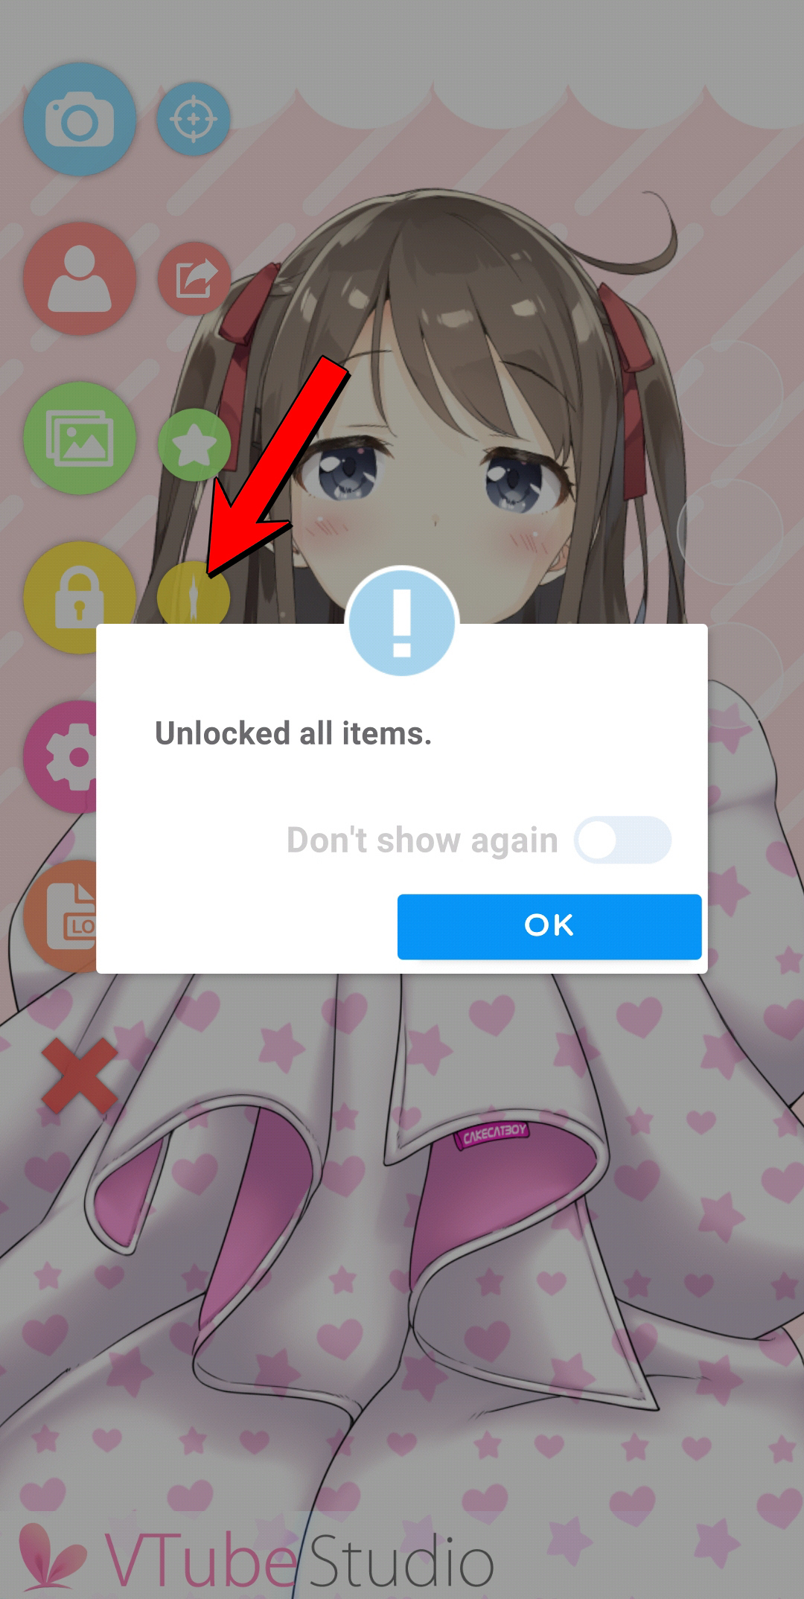 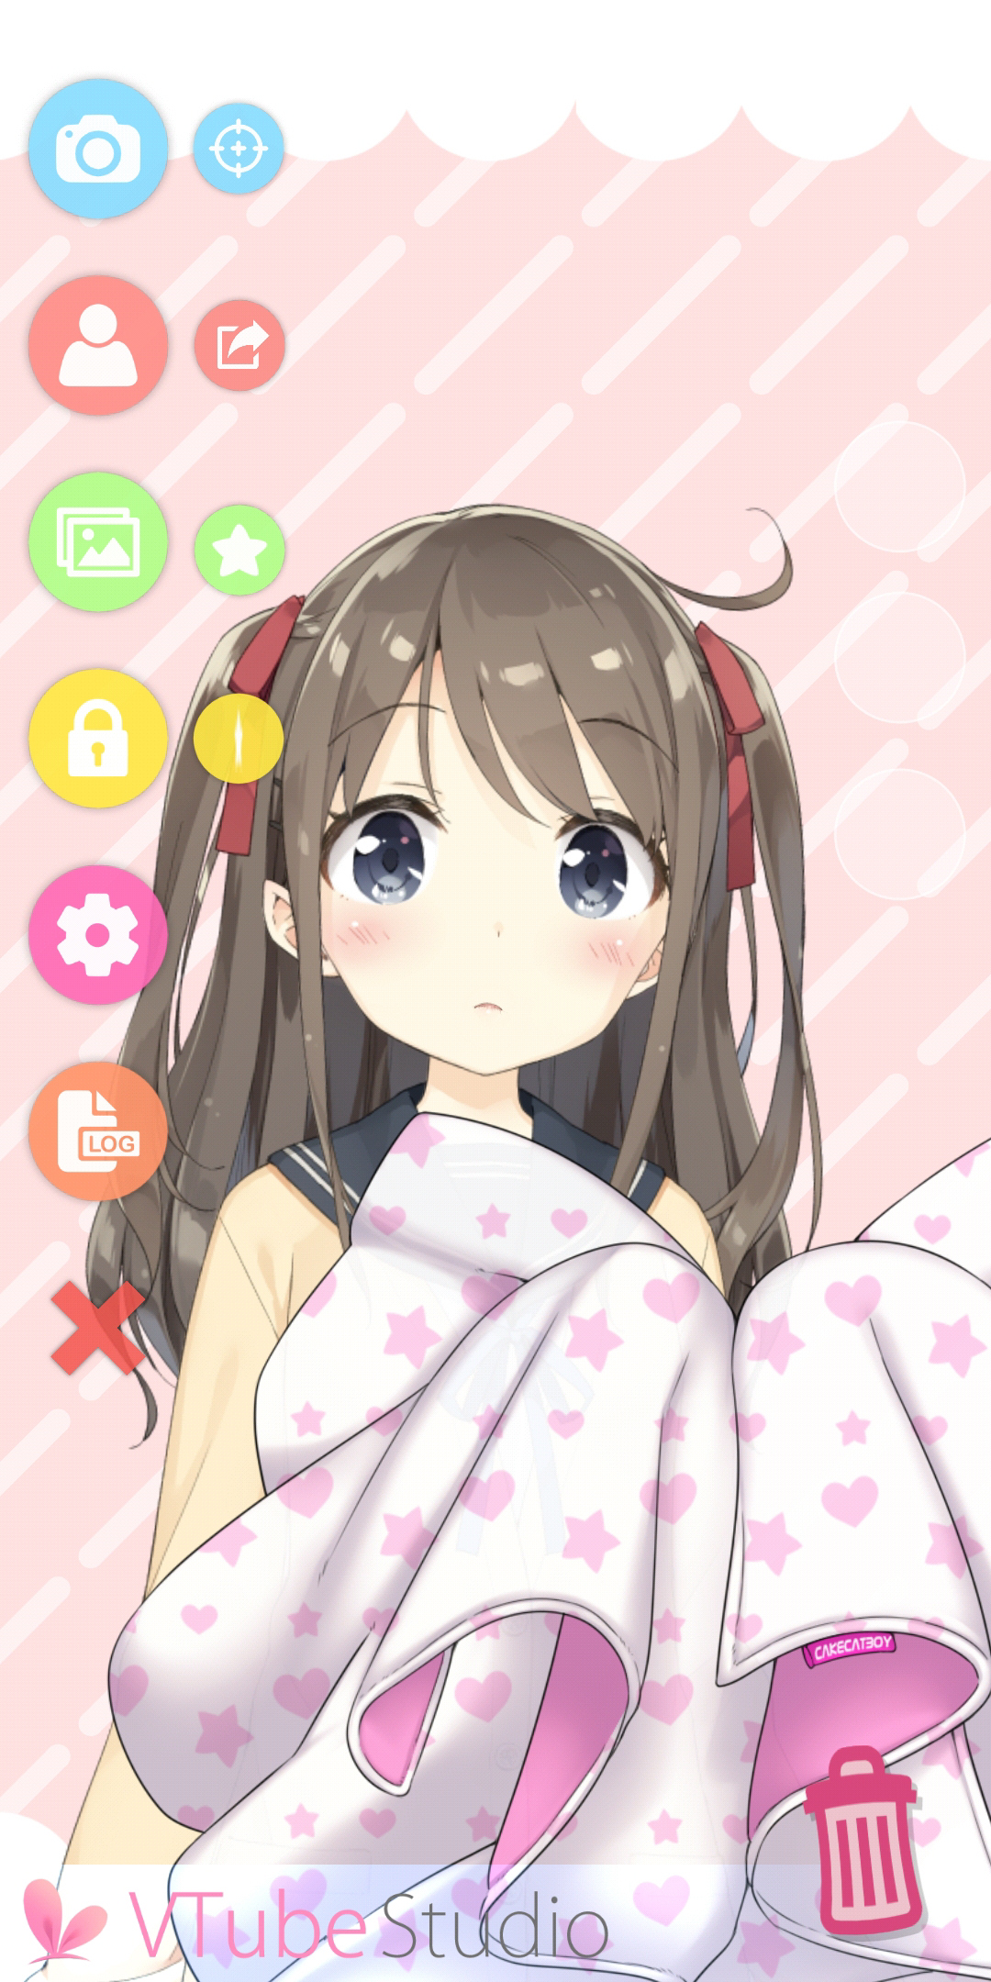

Once the item is in the scene, you can move/scale/rotate it with the usual controls on PC/Mac and iOS/Android. To attach an item to the model, just drop it on there.



The item will be attached to the uppermost ArtMesh in your model at the position where you  
 drop the item. The point of attachment will be the CENTER OF THE ITEM PNG. This can make it

a bit tricky sometimes to attach the item to the correct ArtMesh, so you may need to play

around a little bit to make it work properly. Keep in mind that this feature is in beta.

Once your item is at the correct position, **you can double-tap (double-click) it to lock the position**. That way, you can no longer move, scale or rotate the item until it is unlocked again. If the item is attached to your model, it will still move according to the model movement.

If you move, scale or rotate the Live2D model itself, any locked items attached to the model will also move, scale and rotate with it as you would expect.

**To unlock locked items,** choose the option from the main menu (see arrow in second image). By pressing that button once more, all items will be locked again.

**To delete items from the scene,** simply drag them over the trash can icon in the bottom right. It will only appear if you drag an item near it.



Most of the free included items/props have been provided by @cakecatboy and @7MDigital

on Twitter. They have many other great VTuber assets as well, so make sure to thank them!!

# VTube Studio Files and File Format

All files VTube Studio generates to save your model setup and meta data are fully human-readable, not encrypted and use a JSON format.

Currently, VTube Studio saves all model-related configuration data in a file right next to your Live2D model. The file is called:

***<Your-Live2D-Model-Name>.*vtube.json**

There is no documentation available for the file format at this point, but if you’re interested, just open them up in your favorite text editor. Most things should be relatively self-explanatory. But please be advised that manipulating your model fines manually may result in broken files so please be careful.

# FAQ

## Can my face be accidentally revealed on stream?

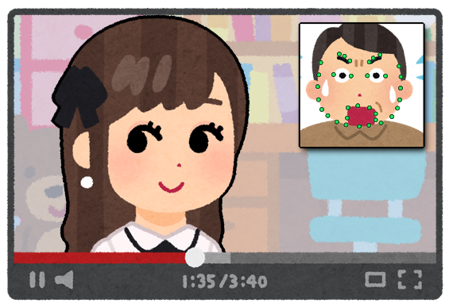

**No, that can’t happen.** VTube Studio uses your smartphone camera just for face tracking and does not store or transmit your face or any raw face tracking data to your PC. Only the calculated parameters are transmitted, so at no point will any video be available on your PC.

If you also want to make sure your face is never shown on your smartphone screen, make sure to set *“Camera Preview”* to *“Never Show”* (see chapter **“Camera Settings”**).



Don’t worry so much that people could see your face. You are beautiful! ♥

## How do I buy VTube Studio? Why should I? Can I use it commercially?

First, download the VTube Studio app from the iPhone or Android App Store. The download itself is free. Then go into the app settings. There’s a big button to buy the PRO version.

The PRO version gives you access to some features not available in the free version, such as being able to stream to your PC for longer than one minute and being able to remove the VTube Studio logo in the app.

Also, you are only allowed to use VTube Studio commercially if you purchased the PRO version. This includes any kind of commercial use, including (but not limited to) monetized YouTube, Twitch, …, streams, superchats, Live2D model commissions, etc.

This only applies to individual creators, smaller VTuber agencies and smaller companies in general. As a bigger company, you will need additional licensing. Please refer to the VTube Studio EULA for more information and/or contact us directly at [vtubestudioapp@gmail.com](mailto:vtubestudioapp@gmail.com)

## Can I try VTube Studio before buying it?

**You can and should!**

The app itself is free and has a PRO version. The free version contains all features (including loading your own models), so please try VTube Studio first before purchasing.

## Can I use my webcam for face tracking instead of my smartphone?

This is not currently supported and not planned in the near future. I won’t rule it out entirely, but don’t expect it anytime soon.

## How can I use VTube Studio together with my friends?

VTube Studio does not support loading multiple models. However, if you want to do a collaboration stream with your friends, that is possible by using Zoom/Discord/Skype/etc. group video chat.

When using Discord for example, just have everyone use the Virtual Webcam feature of VTube Studio and then select that webcam as your main video chat camera in Discord. Alternatively, record using OBS and then use the OBS Virtual Webcam plugin to create a webcam stream for Discord. The person “hosting” the stream/collab can then record their Discord window using OBS, cut out everyone’s streams and use chroma key filters to remove the backgrounds. This works quite well, but you might need the high-quality 1080p video chat upgrade in Discord to get good picture quality.

It is also possible to use OBS over the internet using LAN-Over-Internet tools like Zero Tier One or Hamachi (free up to 5 participants). You could start multiple instances of VTube Studio on the “host” PC and then have people connect to them. Just remember to use different ports for each instance! **Disclaimer:** I have not personally tested this method but users have reported that it works. Of course, there may be network delay.

## Can I use USB instead of WiFi to connect my smartphone?

As long as your smartphone and PC are on the same network, the connection should work. You can connect your smartphone via USB and the use USB tethering to put them in the same network even without WiFi.

## What is the “Virtual Webcam” feature?

**“Virtual Webcam”** (available on Windows only) allows you to record the VTube Studio window (without the UI) and directly make it available as a webcam stream, making it easy to use it in Discord, Zoom, etc.

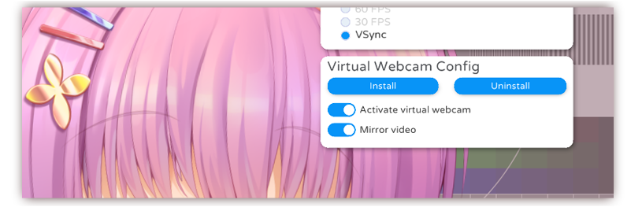

First, you need to install the virtual camera by pressing the “Install” button. This should show a windows console popup and may ask you for administrator privileges, which you’ll have to grant. After successful installation, you can check the “Activate virtual webcam” option to start the webcam stream.

You can now select the stream as normal webcam in Discord, OBS, Zoom, etc. The name of the webcam is **“VTubeStudioCam”**. The virtual webcam also supports streaming with transparent background. Please note that the video quality with the virtual webcam is lower than what you would get when directly recording the window with OBS.

If the installation did not work, make sure to start VTube Studio as admin. If the webcam still does not show up (for example in OBS), make sure OBS is also started as admin.

## My device gets really hot! What is “Streaming Mode” in the smartphone app?

This is unfortunately normal. Your device may get really hot, but with the correct settings, it should not lead to any serious issues such as overheating or crashes.

To reduce heating, there are three things you should do when streaming to PC:

* **Unload your Live2D model on the smartphone.** You do not need to have a model loaded when streaming to PC and having a model open on your smartphone requires a lot of performance, which can be too much for some smartphones.
* **Remove the camera preview.** Rendering the camera preview in the app can also cause some performance issues when done for a long time. Try turning it off.
* **Turn the screen brightness all the way down.** This will significantly reduce the heat produced by your phone.

When using these settings, **streaming for 15+ hours should be no problem** (keep the phone charged). Tested on iPhone X and iPad.

**“Streaming Mode”** automatically removes the model, removes the camera preview and lowers the screen brightness when connecting to your PC. It is recommended to always use streaming mode when streaming to your PC.

## Are there differences between the macOS and Windows version?

Windows supports all features. MacOS does not support transparent backgrounds with OBS and background hotkeys. This means hotkeys will only work on macOS if the VTube Studio window is focused. When for example playing a game at the same time, the hotkeys will not activate.

## Why does my stream to PC/Mac lag?

This is almost always caused by network issues. As a first thing to try, restart your router/switches, PC and smartphone. If the issues persist, check the chapter **“Connection Issues & Troubleshooting”**.

## Why is blinking and eye tracking not supported on Android?

VTube Studio uses Google ARCore on Android. Eye/Blink/Wink-Tracking is not supported by this framework yet. There is no information if/when this will become available. It is possible that it will never be supported.

If and when it is added to ARCore, it will also be supported by VTube Studio.

## I bought the PRO version on Android. Can I transfer it to iOS?

As a general rule, no. Technically, it is not possible as Google and Apple use different app-stores.

However, I may grant a grace period of one month.

If you purchased VTube Studio on Android and want to “transfer” that license to iOS, you can contact me per mail or on Discord. If you do, please first also purchase it on iOS and provide proof of purchase. I will then refund your purchase on Android.

## VTube Studio doesn’t work on my smartphone. What can I do?

Please make sure you’re using a supported device as detailed in the chapter “Supported Devices”.

## The face tracking is going crazy on my iPhone/iPad! What’s going on?

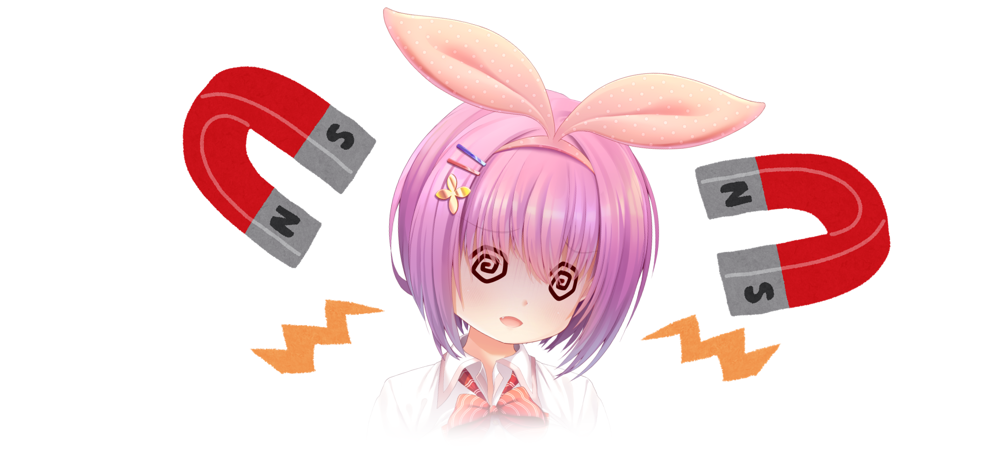

If the tracking mask in the camera preview is flying around or glitching out randomly, this is usually caused by magnetic interference. The iPhone/iPad uses a magnetometer (digital compass) to calculate the device facing direction. Please make sure your device does not have a case with magnets inside and is not leaning against a computer monitor. Having the device on a wireless charger may also cause similar issues.

In some instances, it can also be caused by bad lighting. Make sure you have good, non-colored lighting in your tracking setup. Some colors seem to confuse iOS/Android face tracking. Try going in a different room and see if that helps.

It has also been reported that mirrors somewhere in the camera view can confuse the tracking.

## Why does my iPhone/iPad show the forward-pointing camera?

This means your device is not supported. You should also have seen a popup telling you this when the app starts. For supported devices, see the chapter **“Supported Devices”**.

## Where can I get help/support?

Discord or mail. Check the first page of this document.

## How can I become a VTube Studio Partner?

The partner program is currently closed. Once it is opened again, it will be announced on [Twitter](https://twitter.com/VTubeStudio) so please stay tuned!

## Can I use VTube Studio in my company? How about for TV ads?

Depending on the size of your company, you may need additional licensing. Please see the VTube Studio EULA or contact me for more information.

## I can’t load my Live2D model in VTube Studio. What’s wrong?

First, check the logs if there are any errors. If there are errors in the logs but no error popup was shown, there may be a bug in the app. Please contact me on Discord so I can take care of it.

There have also been cases of Antivirus software blocking the app from reading models. Try disabling them or adding an exception for VTube Studio. One such example is “IObit Malware Fighter”.

## Does VTube Studio store/record any personal data?

**No.**

Specifically, no personal data is stored on the device or sent to any external servers by VTube Studio.

For more information, see the privacy policy on <https://denchisoft.github.io/>

## Who is using VTube Studio? I want to see some examples!

VTube Studio is used by many indie and bigger fulltime VTubers as well as VTuber agencies on a regular basis. Here are some random notable examples in no particular order:

**Agencies**

* Liliana Vampaia --- [[Twitter](https://twitter.com/lilianavampaia)] from [MyHoloTV](https://twitter.com/myholotv)
* Hoshino Char --- [[Twitter](https://twitter.com/hoshinochar)] from [Tsunderia](https://twitter.com/tsunderia_us)
* Kamiko Kana --- [[Twitter](https://twitter.com/kamikokana)] from [Tsunderia](https://twitter.com/tsunderia_us)
* Inukai Purin --- [[Twitter](https://twitter.com/inukaipurin)] from [Tsunderia](https://twitter.com/tsunderia_us)

**Indie VTubers**

* Asagiri Yua --- [[Twitter](https://twitter.com/asagiriyua)]
* Savi --- [[Twitter](https://twitter.com/savisavichan)]
* Yue/Chai --- [[Twitter](https://twitter.com/yueko__)]
* Rosuuri --- [[Twitter](https://twitter.com/rosuuri)]
* BSApricot --- [[Twitter](https://twitter.com/LichVtuber)]
* Artemis of the Blue --- [[Twitter](https://twitter.com/ArtemisVtuber)]
* … and hundreds more! Just search [VTube Studio on Twitter](https://twitter.com/search?q=VTube%20Studio&src=typed_query)!

# Privacy Policy and Licensing

For up-to-date information about licenses and the VTube Studio privacy policy, please check the VTube Studio website: <https://denchisoft.github.io/>

Live2D avatars (except the “Akari” model) are © Live2D Inc. Use of Live2D avatars is governed by the terms listed on the Live2D samples website at <https://www.live2d.com/en/download/sample-data/>

# Further Terms

This project is being developed and maintained by DenchiSoft (<https://twitter.com/DenchiSoft>).

Some of the graphics in this document have been taken from <https://www.irasutoya.com/> in accordance with their usage terms.

**Disclaimer:** This app is an indie production and is not developed or published by Live2D Inc., but is **officially licensed** to use the Live2D Cubism SDK. Do not contact *Live2D Inc.* about any questions regarding VTube Studio.



For business and support inquiries, you may contact DenchiSoft at the following address: [vtubestudioapp@gmail.com](mailto:vtubestudioapp@gmail.com)